Week 4
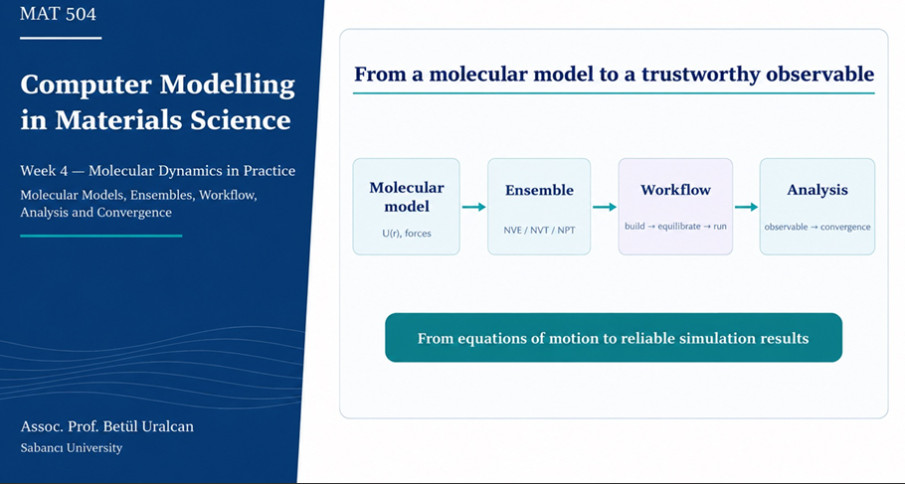

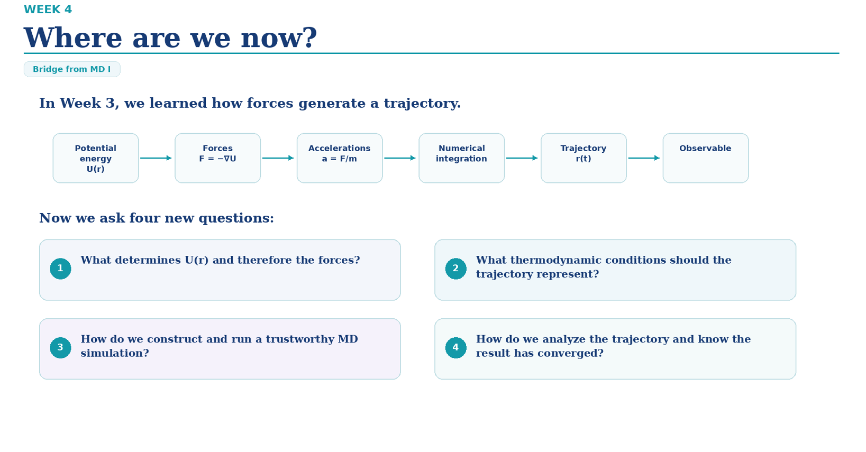
Core Pipeline (Week 3 Review)
$$\text{Potential Energy }U\left(r\right)⟶F=-∇U⟶a=\frac{F}{m}⟶\text{Numerical Integration}⟶\text{Trajectory }r\left(t\right)⟶\text{Observable}$$
Key Questions for Week 4
- Force Field Selection: What determines the potential energy $U\left(r\right)$ and its resulting forces? In an MD force field

- Ensemble & Thermodynamics: What thermodynamic ensemble/conditions should the trajectory represent?

- Simulation Setup & Protocol: How do we construct and execute a trustworthy MD simulation?

- Trajectory Analysis: How do we extract physical observables and verify convergence?

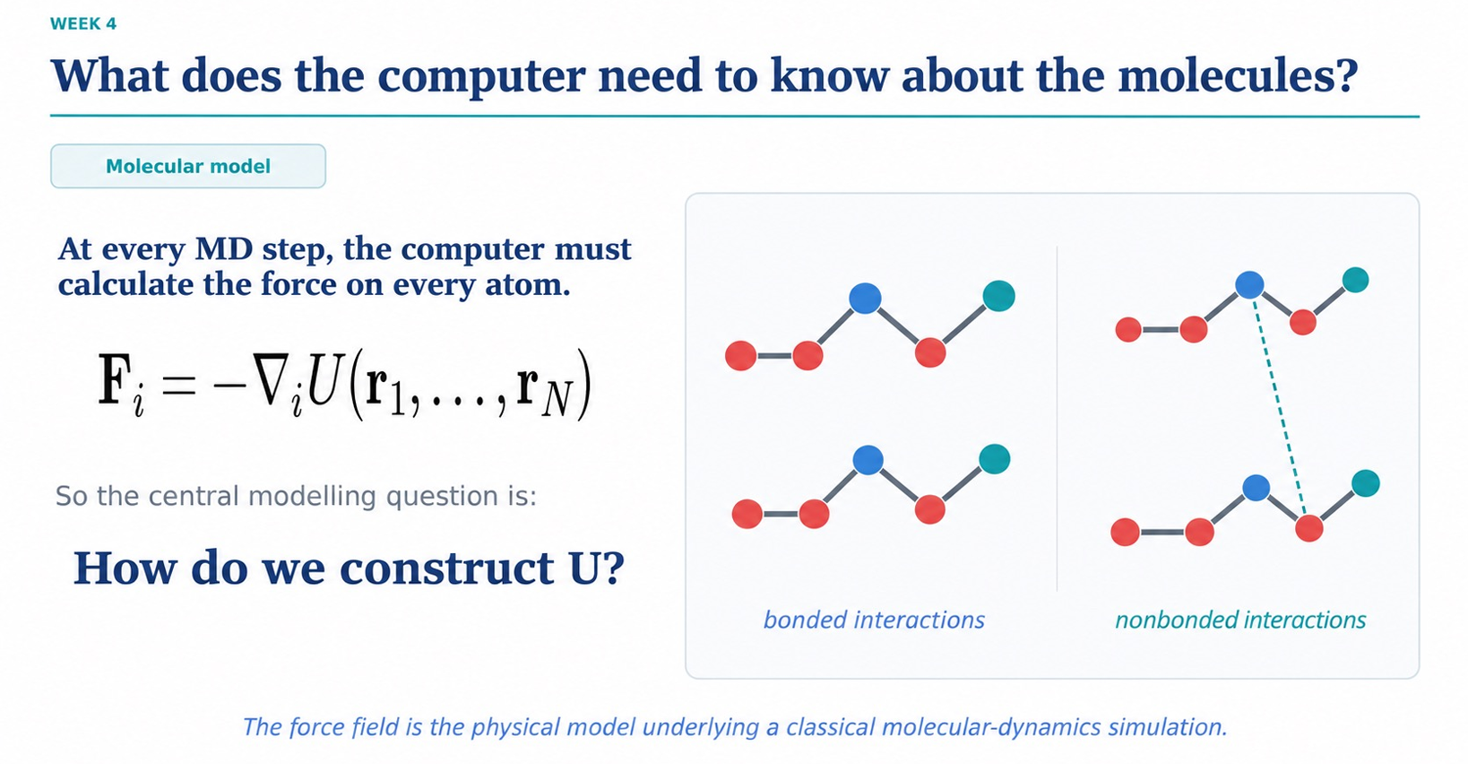
Core Force Equation
At every step, the computer calculates the total force vector $F_{i}$ on each atom $i$ by taking the negative gradient of the potential energy function $U$ with respect to that atom's position:

$$F_{i}=-∇_{i}U\left(r_{1},…,r_{N}\right)$$
Two Main Categories of Potential Energy $U$
- Bonded Interactions: Forces between atoms connected through chemical bonds (covalent bonds, bond angles, dihedral/torsional angles).

- Nonbonded Interactions: Long-range or through-space forces between non-connected atoms (electrostatics and van der Waals interactions).

Key Takeaway
The Force Field is the mathematical function and set of parameters that defines $U\left(r_{1},…,r_{N}\right)$, serving as the physical foundation for any classical MD simulation.

In a 2D system, every atom $i$ has two position coordinates: $\left(x_{i},y_{i}\right)$.

2. Full Force Vector Notation
The total force vector for atom $i$ in 2D is written as:

$$F_{i}=\left(\begin{matrix}F_{ix} \\ F_{iy}\end{matrix}\right)=-\left(\begin{matrix}\frac{∂U}{∂x_{i}} \\ \frac{∂U}{∂y_{i}}\end{matrix}\right)$$
3. Comparing Dimensions (2D vs 3D)
- In 2D: $r_{i}=\left(x_{i},y_{i}\right)⟹F_{i}=\left(-\frac{∂U}{∂x_{i}},-\frac{∂U}{∂y_{i}}\right)$

- In 3D: $r_{i}=\left(x_{i},y_{i},z_{i}\right)⟹F_{i}=\left(-\frac{∂U}{∂x_{i}},-\frac{∂U}{∂y_{i}},-\frac{∂U}{∂z_{i}}\right)$

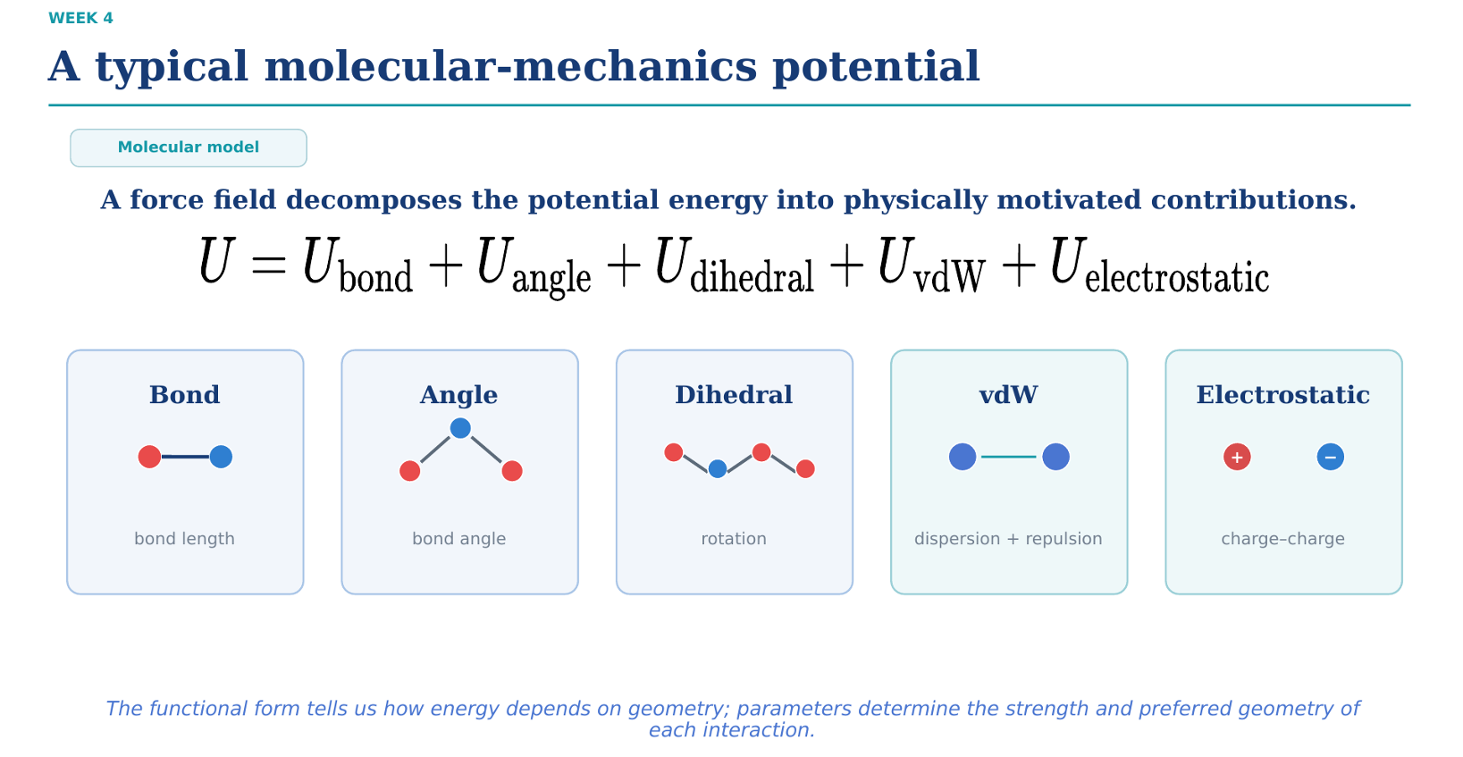
Total Potential Energy Master Equation
The total potential energy $U$ of a system is additive and decomposed into 5 distinct physical terms:

$$U=U_{\text{bond}}+U_{\text{angle}}+U_{\text{dihedral}}+U_{\text{vdW}}+U_{\text{electrostatic}}$$
Breakdown of the 5 Terms
- Bonded Terms (Intramolecular):
  - $U_{\text{bond}}$: Energy cost of stretching/compressing 2-body bond lengths.

  - $U_{\text{angle}}$: Energy cost of bending 3-body bond angles.

  - $U_{\text{dihedral}}$: Energy cost of 4-body bond rotation around a central bond.

- Nonbonded Terms (Intermolecular / Long-Range):
$U_{\text{vdW}}$: van der Waals interactions (combines short-range Pauli repulsion and long-range London dispersion).
$U_{\text{electrostatic}}$: Coulombic charge-charge interactions between partial atomic charges.
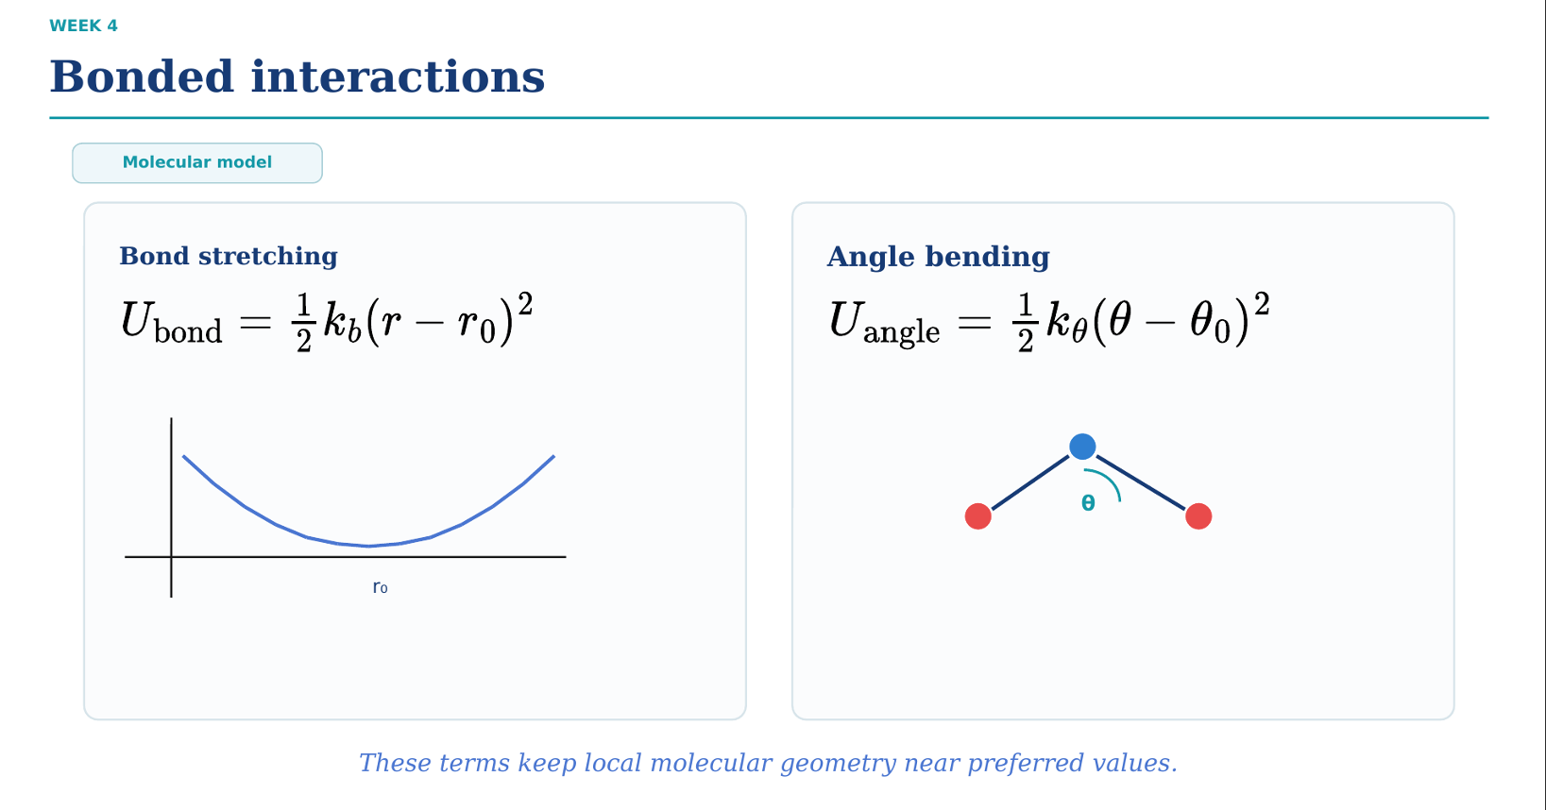
1. Bond Stretching (Harmonic Oscillator)
$$U_{\text{bond}}=\frac{1}{2}k_{b}{\left(r-r_{0}\right)}^{2}$$
- $r$: Current distance between two bonded atoms.

- $r_{0}$: Equilibrium bond length (minimum energy state).

- $k_{b}$: Bond spring constant (stiffness of the bond).

2. Angle Bending (Harmonic Oscillator)
$$U_{\text{angle}}=\frac{1}{2}k_{θ}{\left(θ-θ_{0}\right)}^{2}$$
- $θ$: Current angle between three sequentially bonded atoms.

- $θ_{0}$: Equilibrium bond angle.

- $k_{θ}$: Angle bending force constant.

Key Concept
Both terms use harmonic approximations (quadratic curves centered at equilibrium values $r_{0}$ and $θ_{0}$). Their physical role is to maintain local molecular geometry near preferred equilibrium configurations.

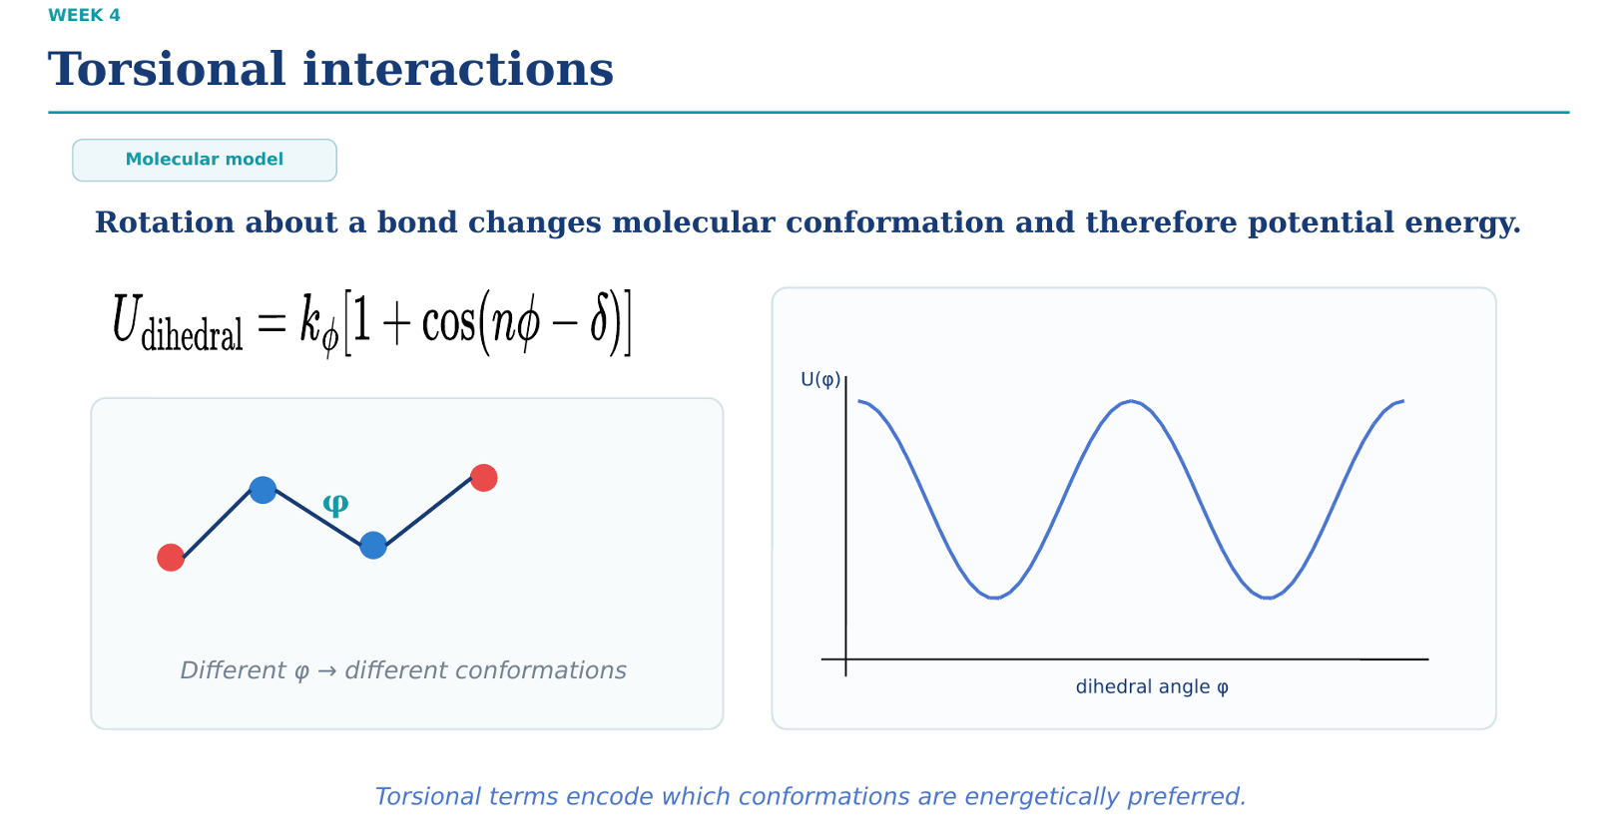
Dihedral Potential Equation
Rotation around a central chemical bond between 4 connected atoms is modeled using a periodic Fourier cosine series:

$$U_{\text{dihedral}}=k_{ϕ}\left[1+\cos\left(nϕ-δ\right)\right]$$
Parameters Defined
- $ϕ$: Dihedral (torsional) angle defined by 4 consecutive atoms.

- $k_{ϕ}$: Energy barrier height (controls rotational stiffness).

- $n$: Periodicity (number of energy minima/maxima in a full ${360}^{∘}$ rotation).

- $δ$: Phase shift (sets the location of the minimum energy conformation).

Key Concept
Unlike bond stretching or angle bending which use harmonic potentials, torsional terms are periodic (using cosine functions). They govern 3D molecular conformations and dictate which 3D arrangements (staggered vs. eclipsed) are energetically favorable.
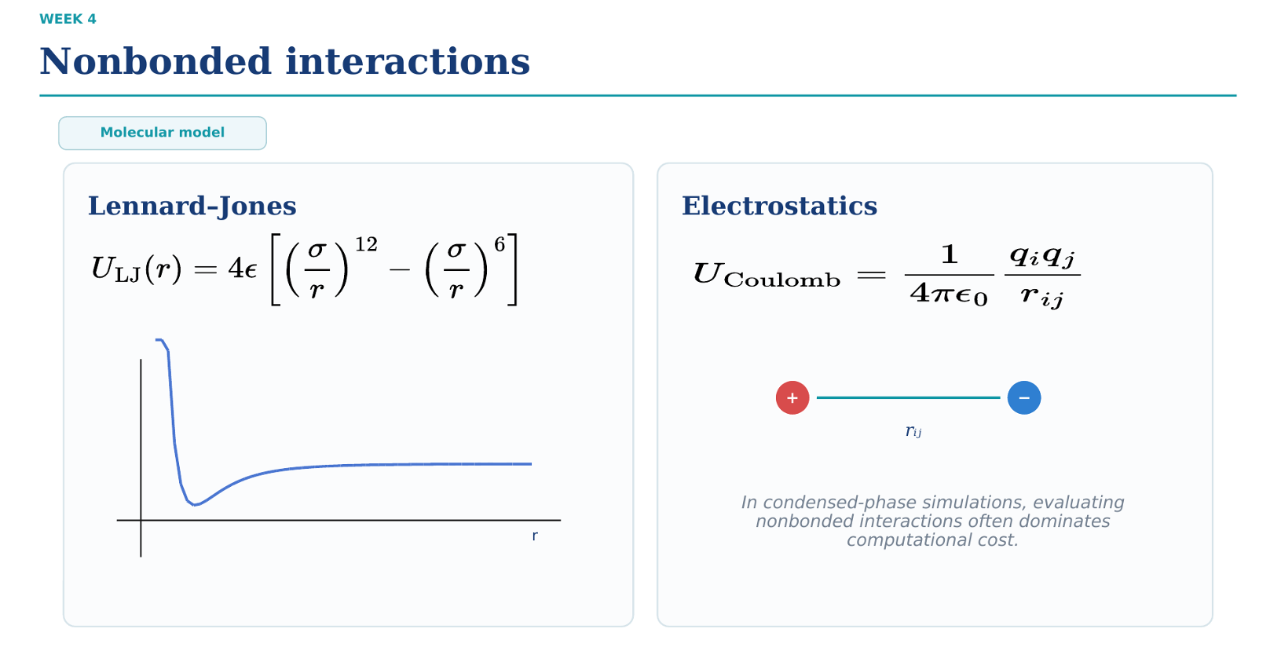
1. Lennard-Jones (12-6) Potential (van der Waals)
$$U_{\text{LJ}}\left(r\right)=4ϵ\left[{\left(\frac{σ}{r}\right)}^{12}-{\left(\frac{σ}{r}\right)}^{6}\right]$$
- ${\left(σ/r\right)}^{12}$ term: Short-range Pauli repulsion (prevents atomic overlap).

- ${\left(σ/r\right)}^{6}$ term: Long-range London dispersion attraction.

- $ϵ$: Potential well depth (interaction energy scale).

- $σ$: Distance at which $U_{\text{LJ}}\left(r\right)=0$ (particle size scale).

2. Electrostatic Potential (Coulomb's Law)
$$U_{\text{Coulomb}}=\frac{1}{4πϵ_{0}}\frac{q_{i}q_{j}}{r_{ij}}$$
- $q_{i},q_{j}$: Partial charges of atoms $i$ and $j$.

- $ϵ_{0}$: Vacuum permittivity.

- $r_{ij}$: Interatomic distance between charges.

Computational Bottleneck Note
Because nonbonded interactions act pairwise between all atom pairs, calculating these nonbonded terms scales as $O\left(N^{2}\right)$ and dominates the computational cost in condensed-phase MD simulations.

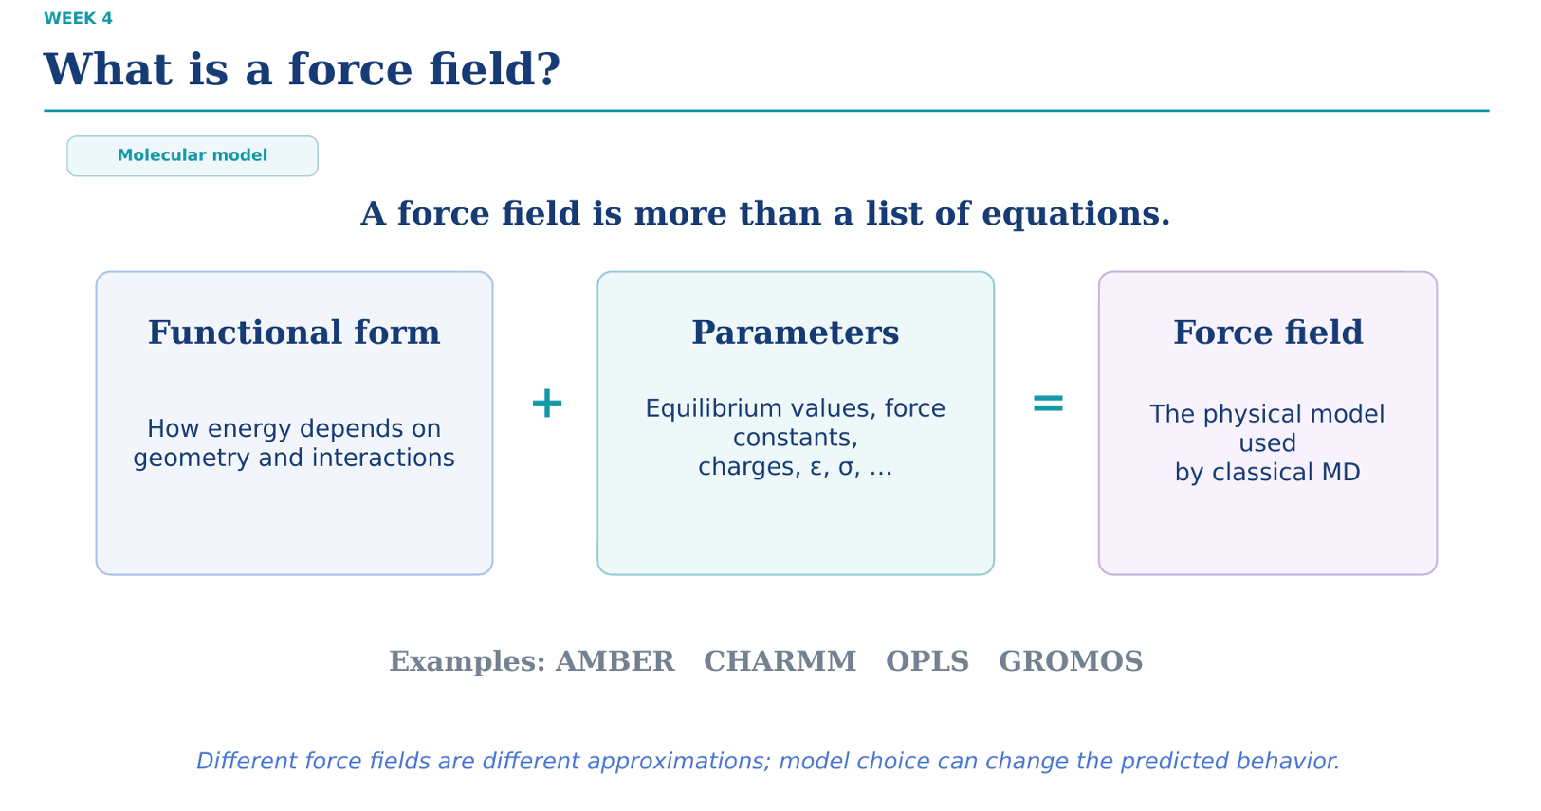Core Definition Equation
$$\text{Functional Form}+\text{Parameters}=\text{Force Field}$$
Component Breakdown
- Functional Form: The mathematical equations defining how potential energy depends on molecular geometry and interactions (e.g., harmonic springs, cosines, LJ 12-6, Coulomb).
- Parameters: The numerical constants required by those equations (equilibrium distances $r_{0}$, angles $θ_{0}$, force constants $k$, partial charges $q$, LJ parameters $ϵ,σ$).

- Force Field: The overall physical model used by classical MD to simulate atomic behavior.

Key Takeaway & Standard Examples
Common standard classical force fields include AMBER, CHARMM, OPLS, and GROMOS. Because different force fields use different parameterizations and approximations, your choice of force field can directly affect the predicted physical behavior of the system.

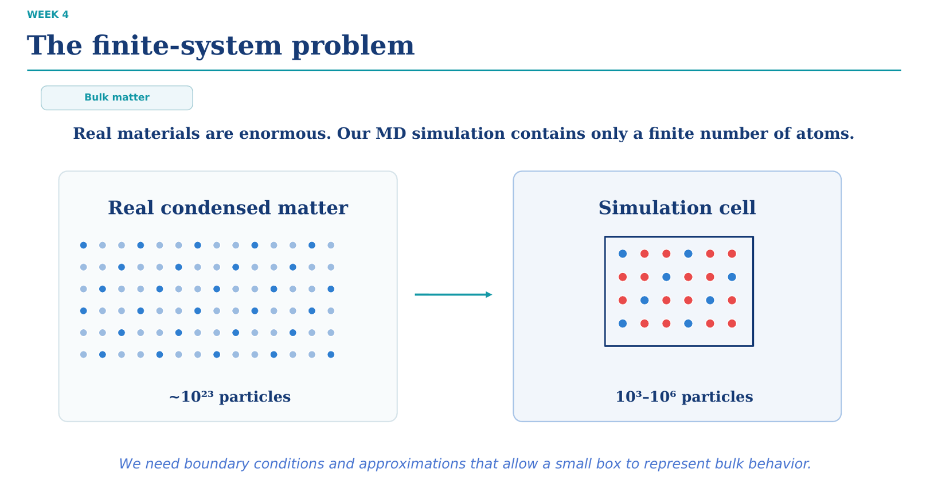Core Dilemma: Scale Mismatch
- Real Condensed Matter: Contains macroscopic quantities of particles ($∼{10}^{23}$ atoms, Avogadro's scale).

- MD Simulation Cell: Computationally restricted to a tiny finite subset (${10}^{3}$ to ${10}^{6}$ particles).

Key Takeaway
Because a finite box has a huge proportion of atoms near its physical walls, unmitigated boundaries create dominant, unphysical surface/wall effects. We must introduce Periodic Boundary Conditions (PBC) and approximations to enable a small simulation box to accurately model infinite bulk material behavior.

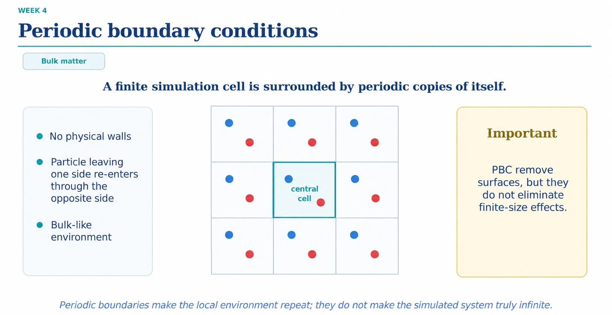How Periodic Boundary Conditions (PBC) Work
- Infinite Tessellation: The central simulation cell is replicated infinitely in all spatial dimensions by periodic copies of itself.
- No Hard Walls: There are no physical container boundaries in the system.
- Particle Recycling: Any particle that leaves one side of the central cell immediately re-enters through the exact opposite face with identical velocity.

- Bulk Environment: Every particle experiences a homogenous, bulk-like local environment.
In this context, homogenous means that every particle experiences an identical bulk environment, with no special "edge" or "surface" particles.

Critical Distinction
PBC successfully removes artificial surface/wall effects, but it does not eliminate finite-size effects. Periodic boundaries merely repeat the local environment; they do not make the simulated system truly infinite.

Your teacher Betül Hocam was 100% correct, and this comes down to how Periodic Boundary Conditions (PBC) and the Minimum Image Convention are implemented in code.
Here is why we sample across all replicas (or use periodic images) for physical properties, but only sum the potential energy $U$ over the primary central box.
1. For Potential Energy $U$: Why Only the Center Replica?
When computing the potential energy $U$ of the system:
- We are simulating a system of $N$ real particles defined inside the primary central box.
- The infinitely repeated "replicas" surrounding the central box are virtual ghosts (copies)—they do not represent separate, independent physical atoms. They are just shifted coordinates of your central $N$ particles:

$$r_{\text{image}}=r_{\text{central}}+n⋅L$$
- If you summed the potential energy over all infinite replicas, the total energy of the universe would be infinite!
- Instead, we sum the potential energy per unit cell ($N$ particles in the center box). For every particle $i$ in the central box, we compute its interaction energy with the nearest image (using the Minimum Image Convention) of every other particle $j$.

Thus, the energy calculation always evaluates $U$ strictly for the $N$ particles inside the central box:

$$U_{\text{total}}=\sum_{i=1}^{N-1}{\sum_{j=i+1}^{N}{U}}\left(r_{ij}^{\text{min}}\right)$$
2ummary Table
Concept | What we do | Why
Potential Energy ($U$) | Calculated for the $N$ central particles only. | Keeps energy finite and non-redundant (energy per box).
Sampling & Forces | Evaluated using the Minimum Image across surrounding replicas. | Eliminates wall/boundary artifacts so particles near edges interact with their true nearest neighbors.

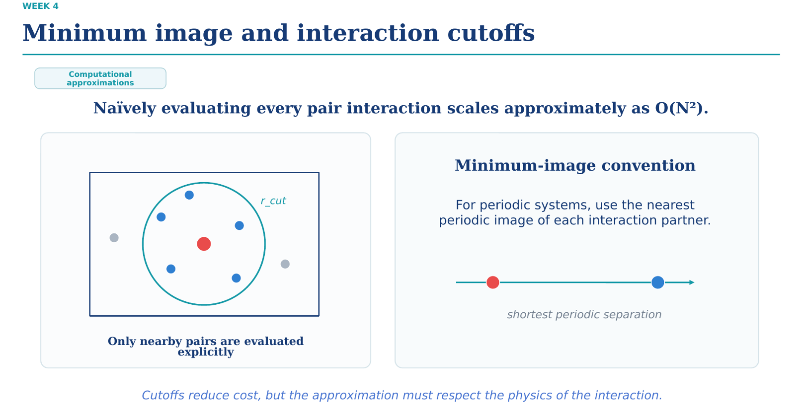
1. The $O\left(N^{2}\right)$ Complexity Problem
Naively evaluating nonbonded forces between every possible atomic pair scales as $O\left(N^{2}\right)$, which becomes computationally intractable for large systems.

2. Two Key Computational Approximations
- Minimum Image Convention: For periodic systems, an atom $i$ interacts only with the single closest periodic image (shortest distance vector) of atom $j$.
- Interaction Cutoff ($r_{\text{cut}}$): Forces and potential energies are explicitly calculated only for atom pairs separated by $r≤r_{\text{cut}}$. Beyond $r_{\text{cut}}$, interactions are truncated to zero or approximated.
Key Constraint
Cutoffs significantly lower computational cost, but $r_{\text{cut}}$ must be chosen carefully to respect the underlying physics (typically $r_{\text{cut}}≤L/2$ to satisfy the minimum image condition).
For one atom, we consider many interactions with different neighboring atoms, but only ONE interaction per target atom.

Here is the exact distinction:
- Many Different Atoms: Atom $i$ interacts with Atom $A$, Atom $B$, Atom $C$, Atom $D$, and all other atoms within its cutoff radius $r_{\text{cut}}$.
- Only ONE Image per Atom: When Atom $i$ interacts with Atom $A$, it only interacts with the single nearest periodic image of Atom $A$ (the Minimum Image Convention). It will not interact with Atom $A$'s original position and its periodic copies in neighboring boxes at the same time.

A Simple Visual Example
Imagine Atom 1 is inside a box with Atom 2 and Atom 3:

- Atom 1 calculates its interaction with Atom 2's nearest image (1 pair interaction).

- Atom 1 calculates its interaction with Atom 3's nearest image (1 pair interaction).

Atom 1 has multiple total interactions (with Atom 2 and Atom 3), but it never double-counts Atom 2 by interacting with two different images of Atom 2.
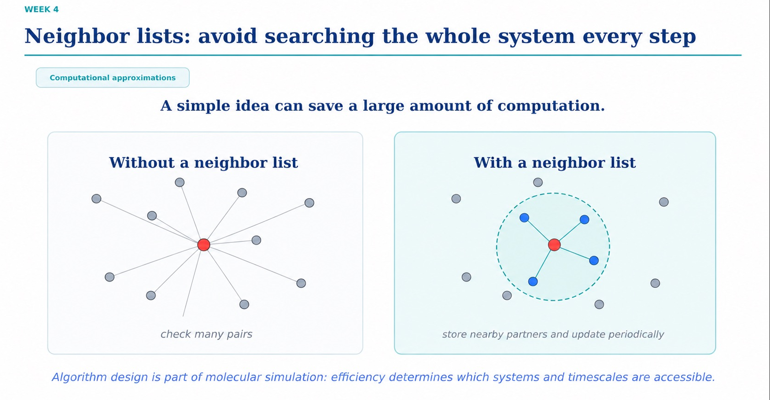1. The Bottleneck: Without a Neighbor List
- Every single timestep, the code checks the distance between every particle pair in the box to see if $r≤r_{\text{cut}}$.
- This requires checking all pairs repeatedly, maintaining a high computational overhead of $O\left(N^{2}\right)$ at every timestep.
2. The Solution: With a Neighbor List (Verlet List)
- Pre-filtered Pairs: For each atom, store a list of candidate partner atoms within a slightly larger buffer skin radius ($r_{\text{list}}=r_{\text{cut}}+r_{\text{skin}}$).
- Periodic Updates: The neighbor list is updated only every $M$ steps (or when particles move beyond the buffer distance), rather than every single step.
- Force Evaluation: On intermediate steps, force calculations are restricted strictly to pairs stored in the pre-built list.

Key Takeaway
Smart algorithm design is just as important as physical modeling in molecular simulations; algorithmic efficiency dictates which system sizes and physical timescales are computationally accessible.

If you check all pairs to build a cutoff or neighbor list, isn't that still $O\left(N^{2}\right)$?
The short answer: Yes, if you check every atom against every other atom directly, it is still $O\left(N^{2}\right)$!
To fix this, simulations use a 2-step solution:
Step 1: Cell Linked Lists (Divides the Box into a Grid)
Instead of comparing all $N$ atoms against each other:
- The simulation box is divided into a 3D grid of smaller sub-cells (voxels), where each cell has a width equal to $r_{\text{cut}}$.

- Every atom is assigned to a specific grid cell based on its coordinates (an $O\left(N\right)$ operation).

- To find neighbors for Atom $i$, you only check atoms inside Atom $i$'s own cell and the 26 immediate neighboring cells.

Because distant cells are ignored completely, you never compute $N^{2}$ distances to build the initial candidate group! This drops the search step down to $O\left(N\right)$.
Step 2: Combine Grid with a Neighbor List (Verlet List)
Even searching nearby grid cells every single timestep takes some effort. So, MD simulations combine both ideas:

- Every 10–20 steps: Use the Cell Grid to find all atoms within a extended skin radius ($r_{\text{cut}}+r_{\text{skin}}$) and store them in a Neighbor List. (Takes $O\left(N\right)$ work).

- For the next 19 steps: Skip all grid searches and distance checks entirely. Calculate forces only for the pairs already saved in the Neighbor List. (Takes $O\left(N\right)$ work).

Summary of the Progression
Method | What it does | Cost per step
Naive Cutoff | Checks distance between all pairs to see if $r≤r_{\text{cut}}$. | $O\left(N^{2}\right)$ — Slow
Grid / Cell List | Divides box into grid; checks only neighboring grid cells. | $O\left(N\right)$ — Fast
Grid + Neighbor List | Builds list from grid once every $M$ steps; reads saved list on intermediate steps. | $O\left(N\right)$ — Fastest

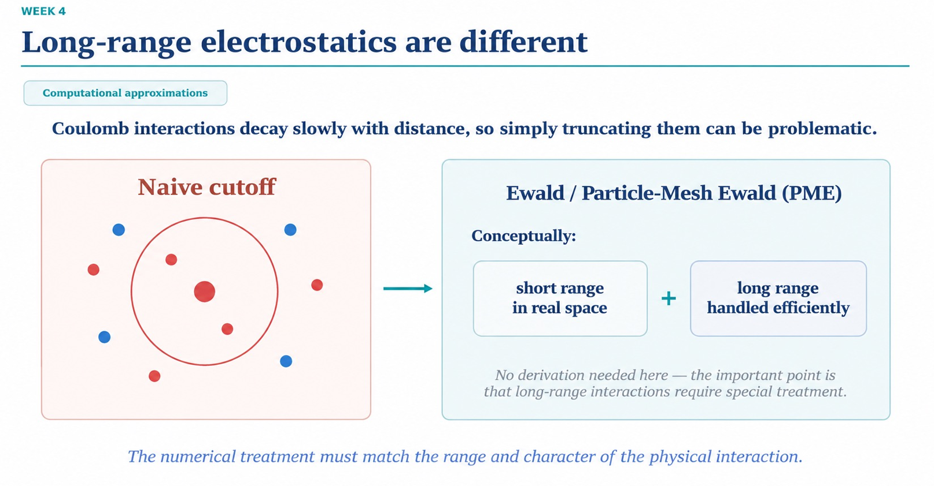
1. Why Electrostatics Break Simple Cutoffs
- Slow Decay: Unlike Lennard-Jones potential ($∼1/r^{6}$), Coulomb interactions decay very slowly with distance ($∼1/r$).
- Problem with Naive Cutoff: Truncating electrostatics at $r_{\text{cut}}$ introduces severe numerical artifacts, energy drift, and unphysical behavior in charged or polar systems.

2. The Solution: Ewald Summation / Particle-Mesh Ewald (PME)
Instead of a simple cutoff, long-range electrostatic interactions are split into two complementary parts:

- Short-Range Component: Calculated directly in real space using standard cutoffs.

- Long-Range Component: Calculated efficiently in Fourier / reciprocal space (using Fast Fourier Transforms in algorithms like PME).

Key Takeaway
The numerical treatment must match the character of the physical interaction: short-range forces (LJ) can be truncated locally, but long-range forces (Coulomb) require special reciprocal-space methods.
For Coulombic (electrostatic) interactions, we cannot simply ignore atoms beyond $r_{\text{cut}}$ because their force drops off too slowly.
The Contrast: Lennard-Jones vs. Coulombic
Potential Type | Formula Decay | Decay Speed | Truncation at rcutr_{\text{cut}}rcut​
Lennard-Jones (Dispersion) | $$U_{\text{LJ}}∝\frac{1}{r^{6}}$$ | Extremely Fast: Drops to nearly $0$ beyond $∼1.0\text{ nm}$. | Safe: Simply cutting off interactions at $r_{\text{cut}}$ works fine without major errors.
Coulombic (Electrostatics) | $$U_{\text{elec}}∝\frac{1}{r}$$ | Extremely Slow: Still significant even at large distances. | Dangerous: Cutting it off creates huge unphysical energy jumps and structural artifacts.
How PME / Ewald Summation Fixes This
Instead of truncating long-range electrostatics, we divide the calculation into two parts:
- Short-Range Part (Real Space): Interactions within $r_{\text{cut}}$ are calculated directly atom-to-atom using standard minimum image cutoffs.

- Long-Range Part (Reciprocal Space): Interactions beyond $r_{\text{cut}}$ are mapped onto a 3D spatial grid (mesh) and solved simultaneously using Fast Fourier Transforms (FFT).
This allows us to account for all infinite long-range electrostatic forces across the periodic images without spending $O\left(N^{2}\right)$ computational time.

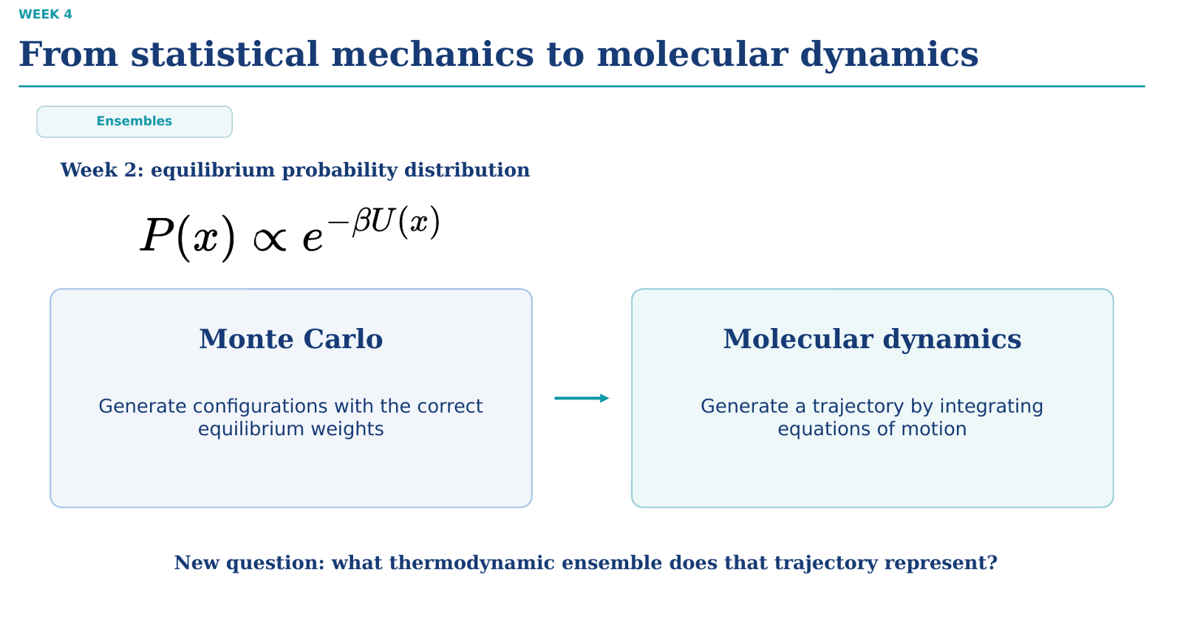
- Statistical Mechanics Foundation: In equilibrium statistical mechanics, the probability of finding a system in a spatial configuration $x$ follows the Boltzmann distribution: $P\left(x\right)∝e^{-βU\left(x\right)}$, where $β=\frac{1}{k_{B}T}$.
- Monte Carlo (MC): Samples configuration space by generating random structural moves and accepting/rejecting them according to the Boltzmann probability weight $e^{-βΔU}$.
- Molecular Dynamics (MD): Generates a time-continuous physical trajectory by numerically integrating Newton's equations of motion ($F=ma=-∇U$) forward in time.
- Core Question: Since MD advances deterministic physical time rather than random moves, what thermodynamic ensemble does that trajectory sample?
In-Depth Comparison: Monte Carlo (MC) vs. Molecular Dynamics (MD)
Both MC and MD aim to calculate ensemble averages of thermodynamic observables:

$$\left\langle A\right\rangle =\int{A}\left(x\right)P\left(x\right) dx$$
However, they navigate phase space using fundamentally different rules.

Feature | Monte Carlo (MC) | Molecular Dynamics (MD)
Propagation Method | Stochastic (Random): Proposes random atom displacements, volume changes, or particle swaps. | Deterministic (Newtonian): Solves $m_{i}\frac{d^{2}r_{i}}{dt^{2}}=F_{i}=-∇_{r_{i}}U$ over small timesteps $Δt$.
Time Scale | No real physical time. Steps represent abstract simulation progress, not real-world seconds. | Real physical time. Trajectory follows true time evolution (e.g., femtoseconds to microseconds).
Dynamical Properties | Cannot measure time-dependent quantities like diffusion coefficients, viscosity, or vibration spectra. | Accurately measures dynamic and transport properties (diffusion, friction, kinetic rates, power spectra).
Kinetic Energy | Generally ignores particle velocities; focuses purely on potential energy $U\left(x\right)$ and configuration space. | Explicitly tracks particle velocities and kinetic energy ($K=\frac{1}{2}\sum{m_{i}}v_{i}^{2}$).
Barrier Crossing | Can perform unphysical moves (e.g., swapping distant molecules or rotating whole domains) to cross energy barriers quickly. | Trapped by physical energy barriers; must overcome activation barriers naturally via thermal fluctuations.
Natural Ensemble | Canonical ensemble ($NVT$) or Isobaric-Isothermal ($NPT$) natively via acceptance rules. | Microcanonical ensemble ($NVE$) naturally due to conservation of total energy.
Answering the Slide's Key Question
"What thermodynamic ensemble does that trajectory represent?"

- Newton's equations conserve total energy ($E=K+U$): In pure Molecular Dynamics without external controls, the system maintains a constant number of particles ($N$), constant volume ($V$), and constant total energy ($E$).

- Natural Ensemble of MD: A basic MD trajectory naturally samples the Microcanonical Ensemble ($NVE$).

- Sampling Other Ensembles: To sample temperature ($T$) or pressure ($P$) instead of fixed total energy ($E$), MD algorithms introduce extended lagrangians or thermostats/barostats (such as the Nosé-Hoover thermostat or Andersen barostat) to simulate the Canonical Ensemble ($NVT$) or Isobaric-Isothermal Ensemble ($NPT$).

Yes, exactly! You nailed it.
Both MC and MD share the exact same ultimate goal in statistical mechanics: calculating equilibrium ensemble averages $\left\langle A\right\rangle$ for a thermodynamic system. However, their capabilities regarding time differ fundamentally:

1. Monte Carlo (MC)
- Time-Independent Properties Only: MC can compute structural, static, and thermodynamic properties (like radial distribution functions $g\left(r\right)$, average potential energy $\left\langle U\right\rangle$, heat capacity, or binding free energies).

- No Real Time: Because MC moves are artificial random jumps, there is no real-world clock ticking. You cannot measure how fast anything happens.

2. Molecular Dynamics (MD)
- Both Time-Dependent AND Time-Independent Properties: MD follows real physical time via Newton's laws ($F=ma$).

- Time-Independent (Static): By taking snapshots along the trajectory after the system reaches equilibrium, you can average them to get the exact same static properties as MC (e.g., average density, structural packing).

- Time-Dependent (Dynamic): Because every timestep represents a real physical duration (e.g., 2 femtoseconds), MD lets you track time-dependent processes like diffusion coefficients ($D$), shear viscosity ($η$), molecular vibrations, folding kinetics, and reaction rates.
Why We Use All Three Ensembles to Match Lab Conditions
In real-world chemistry and biology, experiments are not conducted at a fixed total energy in an isolated vacuum. Instead, they occur under constant temperature (controlled by a water bath or room temperature) and constant pressure (open to atmospheric pressure).

To mirror realistic laboratory conditions in a Molecular Dynamics (MD) simulation, we apply different ensembles across specific phases of the setup:

Step-by-Step Example: Simulating a Drug in Water (Biological Environment)
Suppose you want to simulate a drug molecule solvated in water at human body temperature (${37}^{∘}\text{C}$ or $310\text{K}$) and standard atmospheric pressure ($1\text{ atm}$).

1. Initial Setup (Pre-Ensemble)
You place the drug and water molecules inside a 3D simulation box. Because atoms are placed initial positions manually, some may overlap, creating high steric stress.
2. Temperature Thermalization $→$ $NVT$ Ensemble (Thermostat)
- In the lab: You place your sample container into a temperature-controlled water bath to heat it up to ${37}^{∘}\text{C}$.

- In MD: We hold the box volume ($V$) rigid and activate a thermostat. The thermostat scales atomic velocities until the system's kinetic energy stabilizes at the target temperature ($310\text{K}$).

3. Density & Pressure Equilibration $→$ $NPT$ Ensemble (Thermostat + Barostat)
- In the lab: The liquid inside the beaker rests under $1\text{ atm}$ of atmospheric pressure, settling at its natural liquid density ($≈1{\text{ g/cm}}^{3}$).

- In MD: If we kept the volume fixed, internal pressure could end up completely unphysical (e.g., $-500\text{ atm}$ or $+1000\text{ atm}$). We turn on a barostat alongside the thermostat. The barostat dynamically contracts or expands the box vectors until internal stress balances out at $1\text{ atm}$, ensuring correct liquid density.

4. Main Production Run $→$ $NPT$ or $NVE$ Ensemble
Once the system reaches full thermodynamic equilibrium:

- $NPT$ Run: Kept active if you want to collect data (e.g., binding free energy, conformational changes) under steady experimental temperature and pressure.

- $NVE$ Run: Switched on (turning off thermostats and barostats) if you want to measure pure kinetic properties (such as exact diffusion rates or velocity autocorrelation functions) free from external numerical forces.

Summary of Ensembles in MD Workflows
Ensemble | Control Mechanism | Practical Purpose in Simulation
$$NVT$$ | Thermostat | Thermalization: Stabilizes the system at target experimental temperature without altering box geometry.
$$NPT$$ | Thermostat + Barostat | Equilibration & Sampling: Adjusts box volume to reach true physical density and atmospheric pressure.
$$NVE$$ | Unassisted Newton's Laws | Pure Dynamics: Tracks true physical trajectories and transport properties without artificial friction terms.

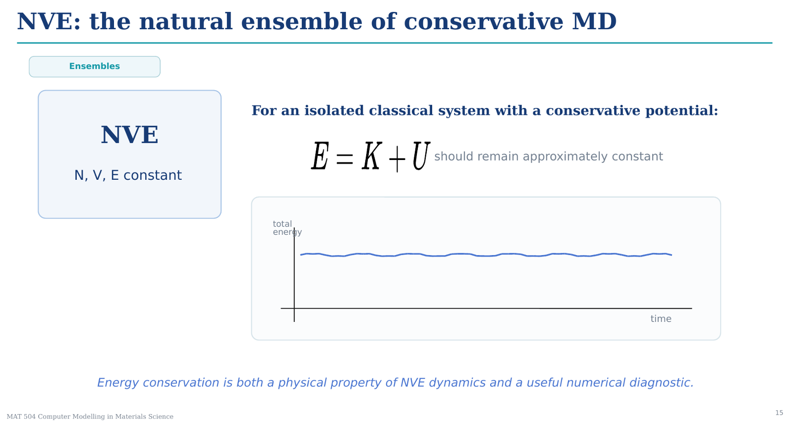
1. Conservation Law in NVE
- Conservative Potential: In an isolated system without external forces or thermostats, total energy is strictly conserved according to Newton's mechanics:

$$E=K+U≈\text{constant}$$
- Energy Exchange: Kinetic energy ($K$) and potential energy ($U$) continuously convert into one another during particle collisions, but their sum ($E$) remains fixed over time.
2. Dual Role of Energy Conservation
- Physical Property: Reflects the true physics of an isolated classical system operating under conservative forces.
- Numerical Diagnostic: Serves as a vital quality check for the simulation. If total energy drifts significantly over time in an $NVE$ run, it signals a numerical issue (such as a timestep $Δt$ that is too large, poor potential truncation, or unstable integrator logic).
Here is why each of those three numerical issues causes the total energy to drift in an $NVE$ simulation:
- Timestep ($Δt$) Too Large (Overshooting)

  - The Problem: The computer updates atom positions in discrete time jumps ($Δt$). If the jump is too big, an atom jumps straight into the repulsive core of another atom instead of stopping smoothly.

  - The Result: The algorithm computes an artificially massive force, shooting the atom out at extreme speeds. This adds fake kinetic energy ($K$) to the system, causing the total energy ($E$) to blow up over time.

- Poor Potential Truncation (Energy Jumps at $r_{\text{cut}}$)
  - The Problem: When an atom steps across the cutoff boundary ($r_{\text{cut}}$), its interaction potential energy instantly drops from a non-zero value to zero.

  - The Result: This sudden step-function discontinuity acts like a sharp numerical cliff. Every time atoms cross this boundary, energy is abruptly added or removed from the system, causing the total energy line to drift up or down.

- Unstable Integrator Logic (Accumulated Rounding Errors)

  - The Problem: Non-symphetic numerical integrators (like basic Euler integration instead of Velocity Verlet) do not preserve phase-space volume over time.

  - The Result: Small mathematical approximation errors accumulate at every single timestep. Over thousands of steps, these tiny mathematical errors compound, causing the energy to steadily rise or fall instead of staying perfectly flat.
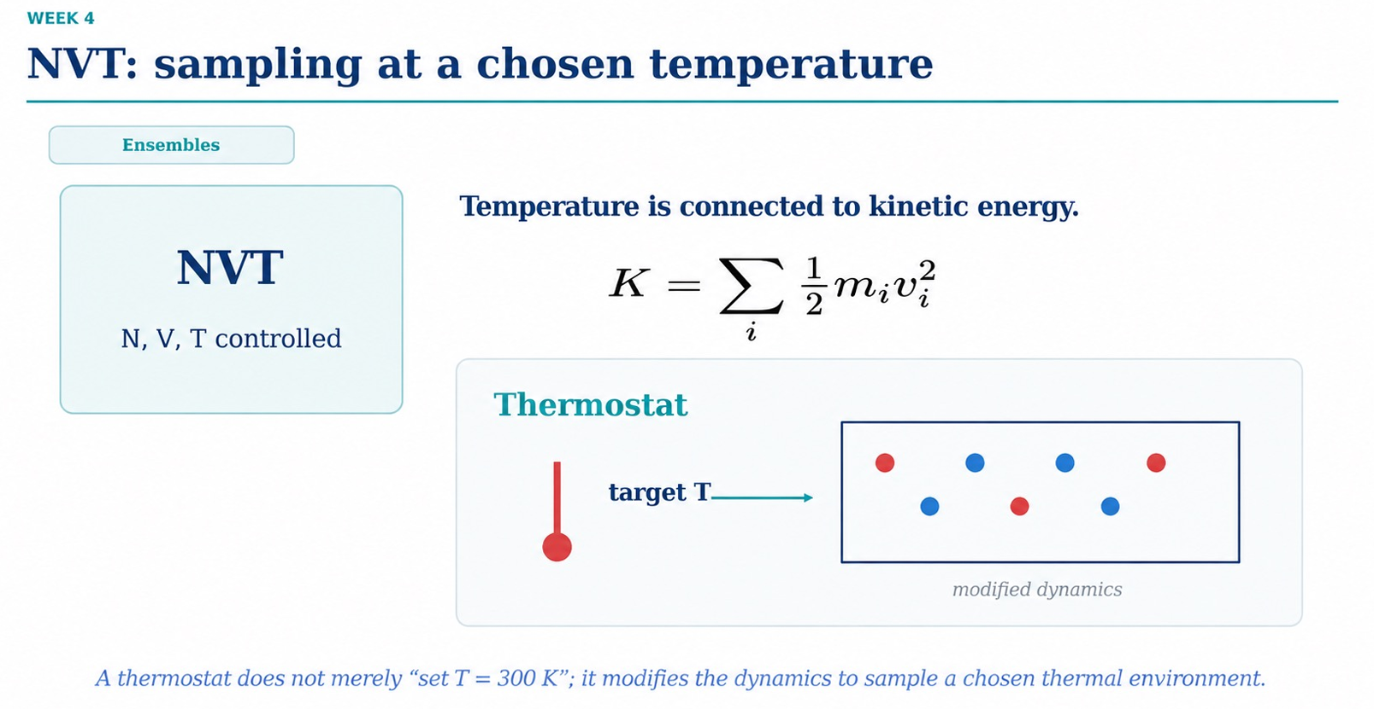
1. Linking Temperature to Kinetic Energy
- Statistical Connection: Macroscopic temperature ($T$) is directly proportional to the average microscopic kinetic energy ($K$) via the Equipartition Theorem:

$$\left\langle K\right\rangle =\sum_{i}{\frac{1}{2}}m_{i}v_{i}^{2}=\frac{3}{2}Nk_{B}T$$
- Controlling $T$ Means Controlling Velocities: To maintain a constant temperature, the simulation must regulate particle speeds.
2. Role of the Thermostat
- Modified Dynamics: A thermostat does not simply freeze the temperature to a flat value like $T=300\text{ K}$. It modifies the equations of motion (adding friction or stochastic velocity scaling) to exchange thermal energy with a virtual heat bath.
- Thermal Fluctuations: It ensures the system correctly samples the Canonical ($NVT$) ensemble probability distribution ($P∝e^{-βU}$), allowing natural thermal fluctuations around the target temperature.

Key Takeaway
A thermostat is an algorithm that alters standard Newtonian dynamics so the trajectory explores a defined thermal environment rather than an isolated $NVE$ trajectory.
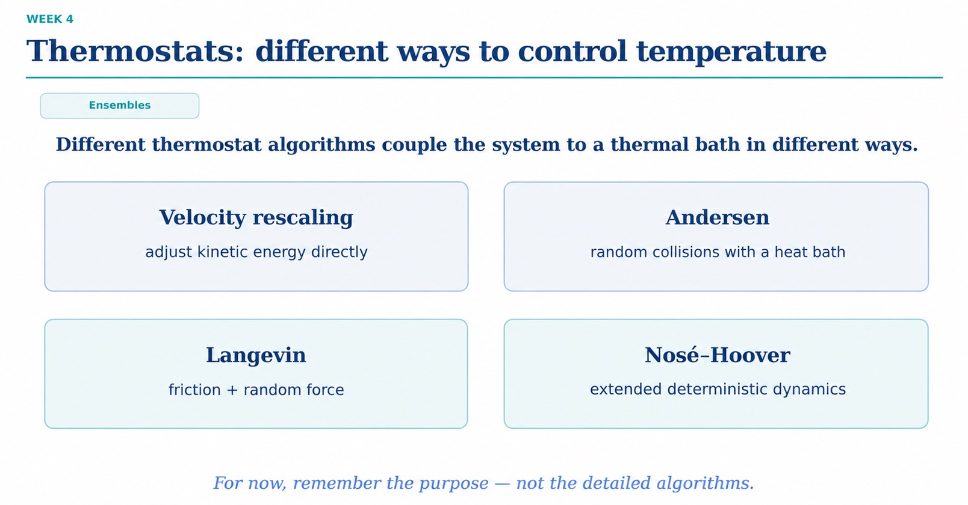Different thermostat algorithms couple the simulation system to a virtual thermal bath, each using a unique algorithmic mechanism:
- Velocity Rescaling (e.g., Berendsen): Adjusts kinetic energy directly by multiplying particle velocities by a scaling factor $λ$ based on the difference between instantaneous temperature and target temperature.
- Andersen Thermostat: Simulates random collisions with a thermal bath by periodically picking random particles and resetting their velocities from a Maxwell-Boltzmann distribution.
- Langevin Dynamics: Adds stochastic noise (random force) and a drag term (friction) directly into Newton's equations of motion to model solvent impact and heat exchange.
- Nosé-Hoover Thermostat: Introduces extended deterministic dynamics by adding a continuous, dynamical friction variable (a thermal bath degree of freedom) into the Lagrangian equations.

Comparison of the 4 Thermostat Types
Thermostat | Mechanism | Canonical Ensemble (NVTNVTNVT)? | Preserves True Dynamics / Trajectory? | Best Used For
Velocity Rescaling | Scales $v$ directly toward target $T$. | No (suppresses natural $T$ fluctuations). | No (disrupts velocity momentum). | Initial system warm-up and fast heating phases.
Andersen | Random velocity resets via virtual collisions. | Yes | No (destroys velocity autocorrelation/diffusion). | Monte Carlo-like structural sampling in $NVT$.
Langevin | Balances viscous drag ($-γv$) with random kicks. | Yes | No (acts like implicit viscous solvent). | Coarse-grained simulations, implicit solvent models.
Nosé-Hoover | Smooth, continuous friction via extended Lagrangian. | Yes | Yes (fully deterministic and time-reversible). | Production $NVT$ runs and accurate dynamic properties.
Key Takeaway
At this high level, focus on the purpose: all thermostats exist to control $T$ by coupling to a heat bath, but you must select the right algorithm based on whether you need strict canonical sampling ($NVT$), physical velocity dynamics, or rapid thermalization.

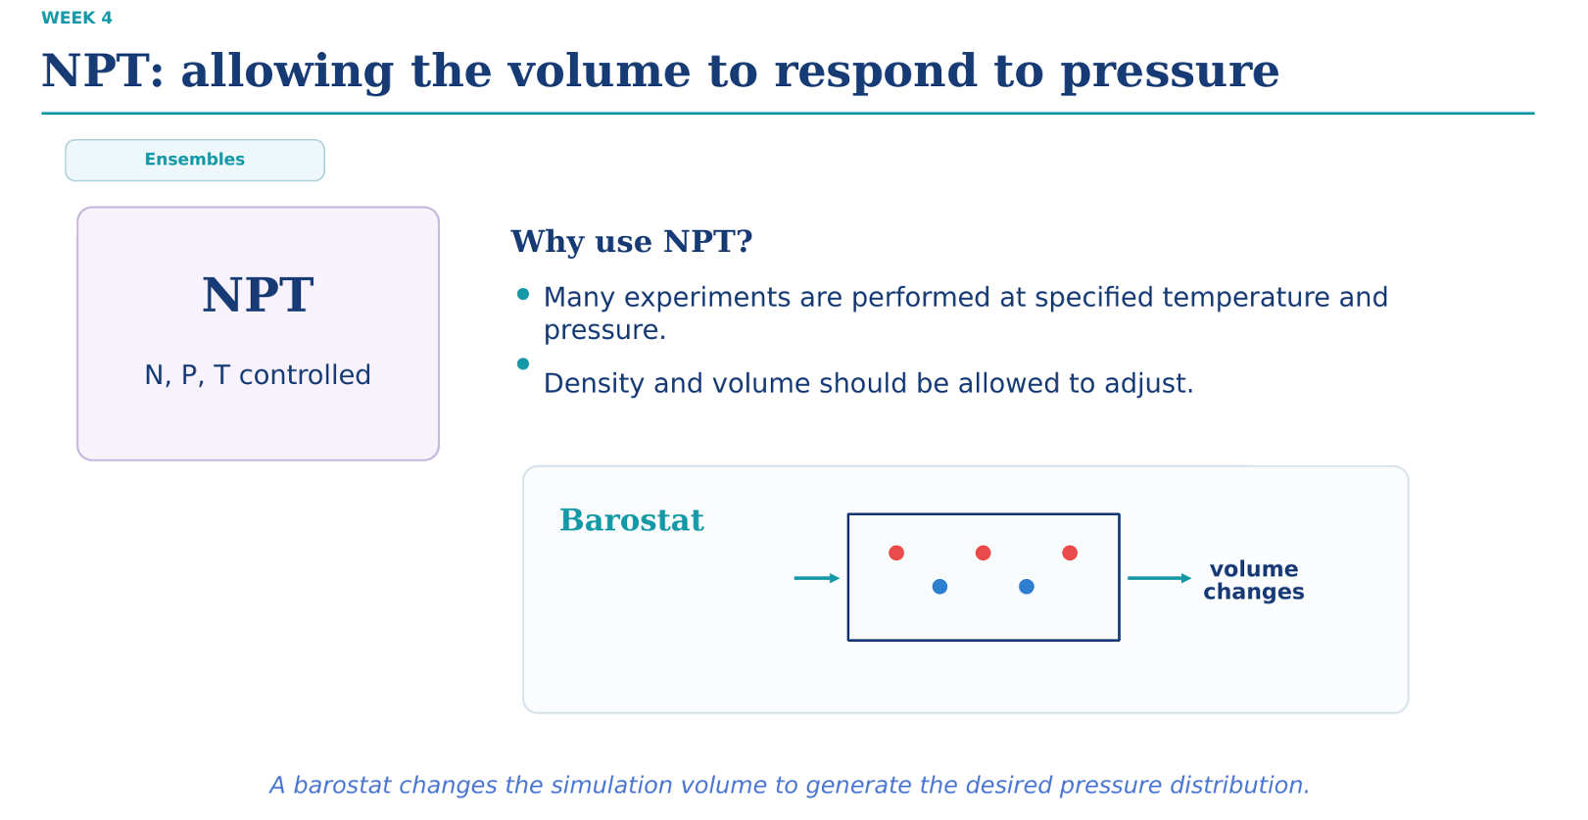
1. Motivation for NPT (Isobaric-Isothermal Ensemble)
- Experimental Relevance: Most real-world laboratory experiments occur at controlled temperature (e.g., room temperature) and atmospheric pressure (1 atm) rather than fixed volume.
- Dynamic Density: The simulation box volume ($V$) must be flexible so the system's equilibrium density can adjust naturally to match external conditions.
2. Role of the Barostat
- Mechanism: A barostat dynamically scales the simulation box dimensions (and particle coordinates) up or down based on the difference between internal instantaneous virial pressure and target external pressure.
- Ensemble Control: While a thermostat scales velocities to match target $T$, a barostat scales spatial volume to sample the correct $NPT$ probability distribution ($P∝e^{-β\left(U+PV\right)}$).

Key Takeaway
A barostat acts as a flexible piston for your simulation box, adjusting $V$ so the system reaches its physical equilibrium density under a target external pressure $P$.
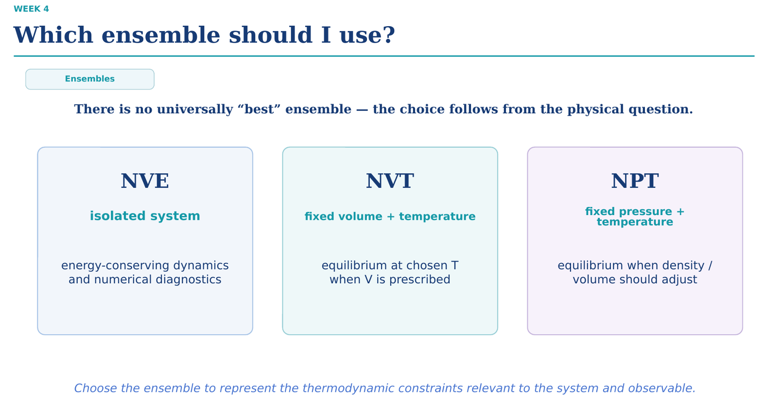
Slide Summary: Which ensemble should I use?
- No Universal "Best": There is no single superior ensemble in Molecular Dynamics; the choice depends entirely on the physical question, the constraints of the system, and the target observable.

Ensemble | System State | Primary Use Cases
NVE | Isolated system | Energy-conserving dynamics, testing numerical integrator stability, and measuring pure dynamic transport properties without artificial thermostat drag.
NVT | Fixed volume + temperature | Sampling equilibrium states at a prescribed temperature when the system volume is known or fixed (e.g., thermalization, fixed-lattice solids).
NPT | Fixed pressure + temperature | Simulating realistic experimental conditions where system volume and density must adjust dynamically to reach equilibrium (e.g., liquids, biological membrane bilayers).
Selection Decision Tree for Practical Workflows
- Are you preparing a initial system structure?
  - Use NVT first to safely bring system temperature to target without volume fluctuations causing instabilities.
- Does your system need to reach physical density under atmospheric conditions?
  - Switch to NPT so the barostat can expand or contract the box until internal pressure matches external $P$.
- Are you measuring time-correlation functions or numerical integrator performance?
  - Switch to NVE once equilibrium is reached to track unperturbed Newtonian trajectories.

Core Takeaway
Choose the thermodynamic ensemble that directly reflects the physical constraints of the real-world system or target observable being studied.

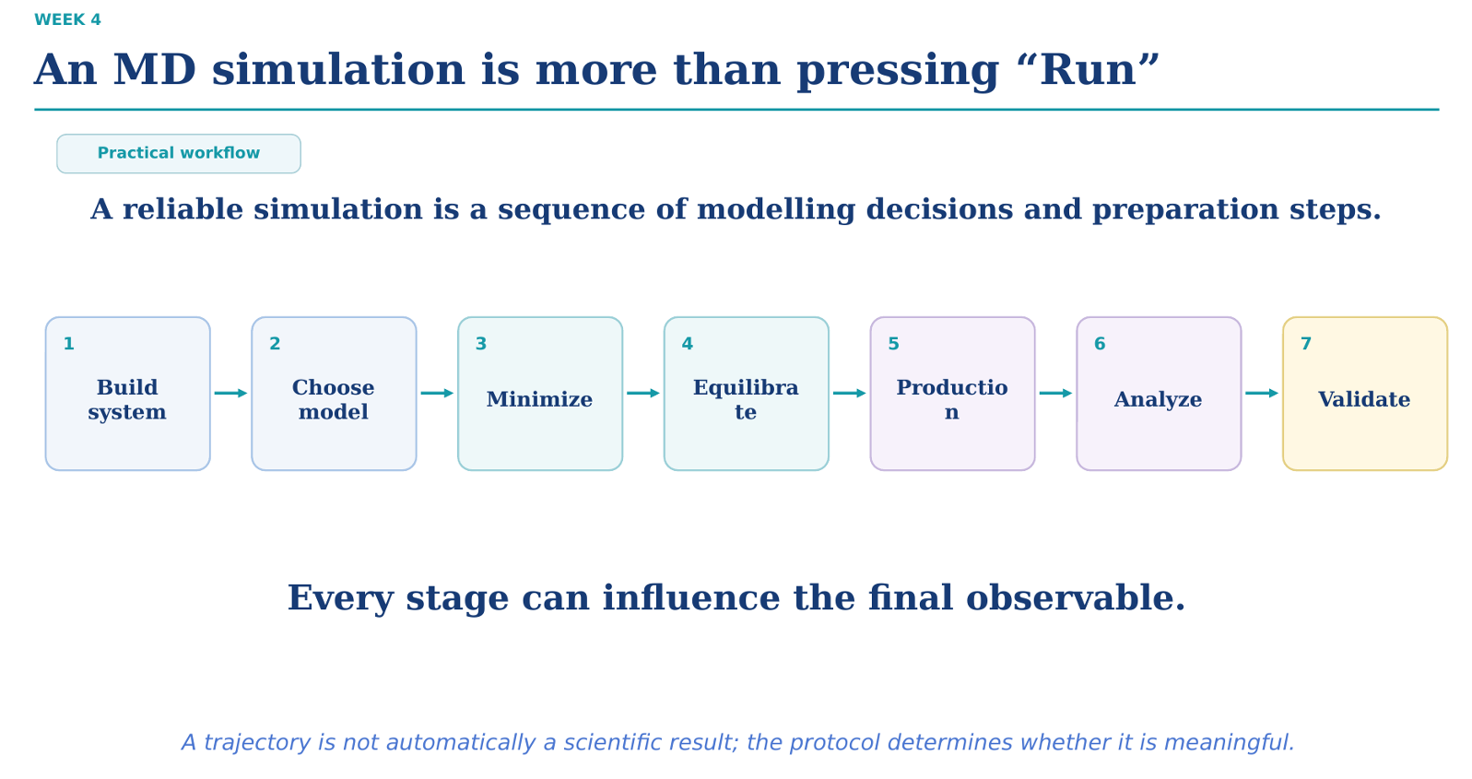
7-Step MD Simulation Workflow
- Build system: Set up initial 3D coordinates, box dimensions, and solvent/ions.

- Choose model: Select force field, potentials, cutoffs, and electrostatics (e.g., PME).

- Minimize: Remove steric overlaps and high forces to prevent system explosion.

- Equilibrate: Warm up ($NVT$) and stabilize density/pressure ($NPT$).

- Production: Run main MD trajectory to sample equilibrium data.

- Analyze: Compute physical properties (e.g., RDF, diffusion coefficients).

- Validate: Compare results against experimental data or theoretical benchmarks.

Core Takeaway
A raw trajectory is not automatically a scientific result—every setup decision determines whether your simulation output is meaningful.
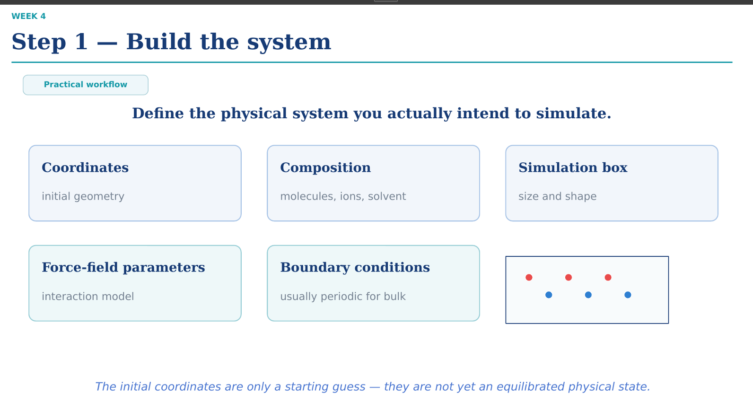
- Coordinates: Initial 3D spatial arrangement of all atoms (starting geometry).

- Composition: Defining the exact molecular species, solvent molecules, and counter-ions.

- Simulation box: Setting the size and geometry of the simulation domain.

- Force-field parameters: Assigning mathematical models for interatomic potentials and forces.

- Boundary conditions: Applying boundary setups (typically Periodic Boundary Conditions for bulk phase).

Core Takeaway
Initial coordinates are merely a starting guess—they represent a computational starting point, not an equilibrated physical state.
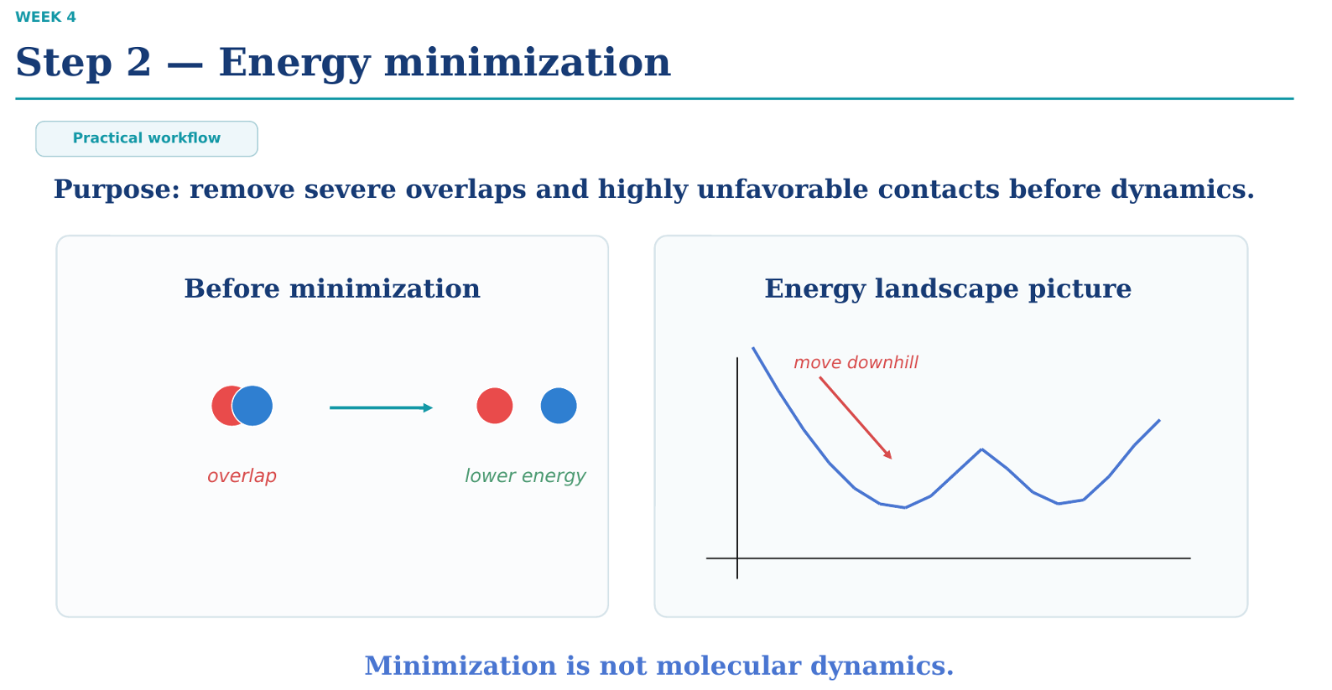
Slide Summary: Step 2 — Energy minimization
- Primary Purpose: Remove severe steric overlaps and highly unfavorable atomic contacts (clashes) in the initial coordinates prior to running dynamics.
- Mechanism: Relocates atoms iteratively to "move downhill" on the potential energy surface toward a nearby local minimum.
- Key Distinction: Minimization is non-physical optimization (e.g., Steepest Descent or Conjugate Gradient), not Molecular Dynamics—there are no particle velocities, kinetic energies, or time steps involved.
Key Takeaway
Without energy minimization, initial atomic clashes produce massive repulsive forces ($F=-∇U→∞$), causing instantaneous velocity spikes that instantly explode the simulation.
Energy Minimization: Pure math optimization—it looks at the steepness (gradient) of the slope and systematically walks straight downhill to lower energy.
Monte Carlo: Thermodynamics/Physics—it makes random trial moves and accepts them using probabilities so it can explore the entire landscape (including going uphill).

Yes, exactly right!

In Monte Carlo (MC)
- Uses Potential Energy $U\left(r\right)$ ONLY: MC randomly moves atoms and calculates the change in energy ($ΔU=U_{\text{new}}-U_{\text{old}}$) to decide if a move is accepted or rejected.

- No Forces: It never calculates forces ($F$).

In Molecular Dynamics (MD)
- Uses Forces ($F$) AND Potential Energy ($U$):

  - Forces are calculated directly from energy slopes: $F_{i}=-∇_{r_{i}}U\left(r\right)$.

  - Forces move the atoms forward in time using $F=ma$.

  - Potential Energy ($U$) is continuously tracked along with Kinetic Energy ($K$) to verify total energy conservation ($E=K+U$).
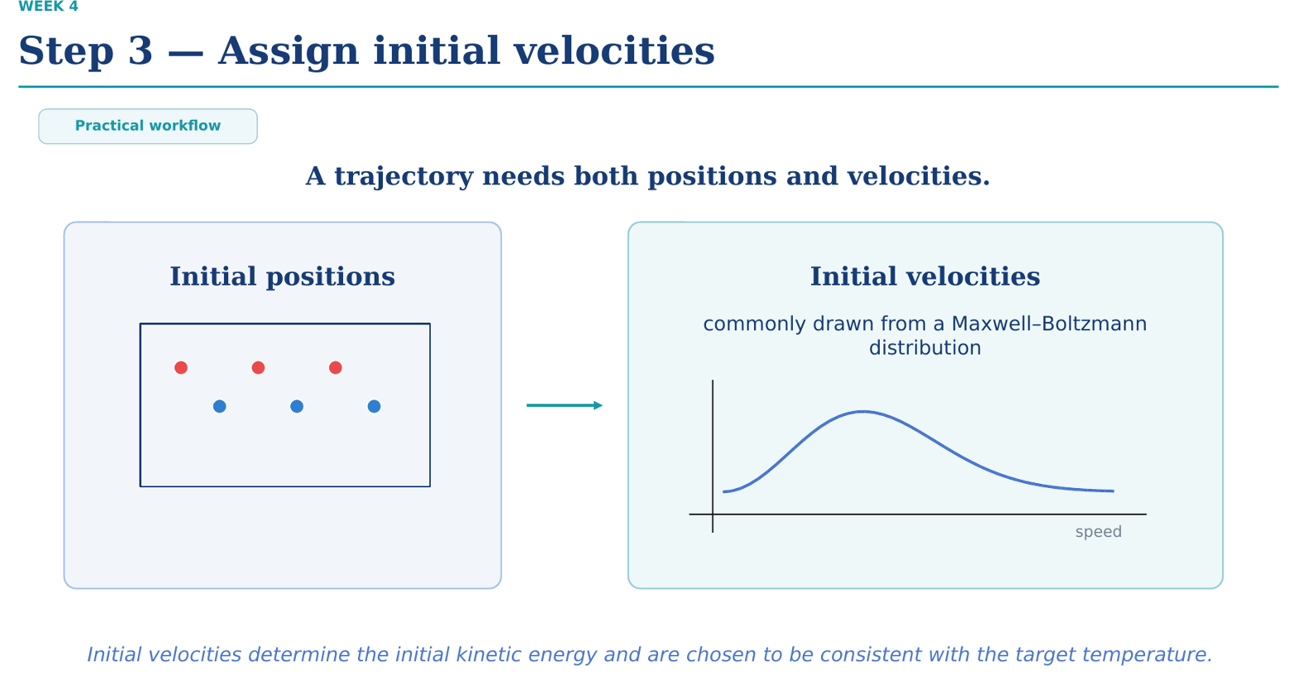
Slide Summary: Step 3 — Assign initial velocities
- Positions + Velocities Needed: To integrate Newton's equations ($F=ma$), MD requires both particle coordinates ($r$) and starting velocities ($v$).

- Maxwell-Boltzmann Sampling: Initial velocities are randomly generated from a Maxwell-Boltzmann velocity distribution matched to your target temperature $T$:

$$P\left(v_{x}\right)∝\exp\left(-\frac{mv_{x}^{2}}{2k_{B}T}\right)$$
- Zero Net Momentum: The algorithm removes any net translational drift ($\sum{m_{i}}v_{i}=0$) so the system box doesn't drift through space.

Key Takeaway
Initial velocities set the starting kinetic energy of your system to match the target temperature before integration begins.

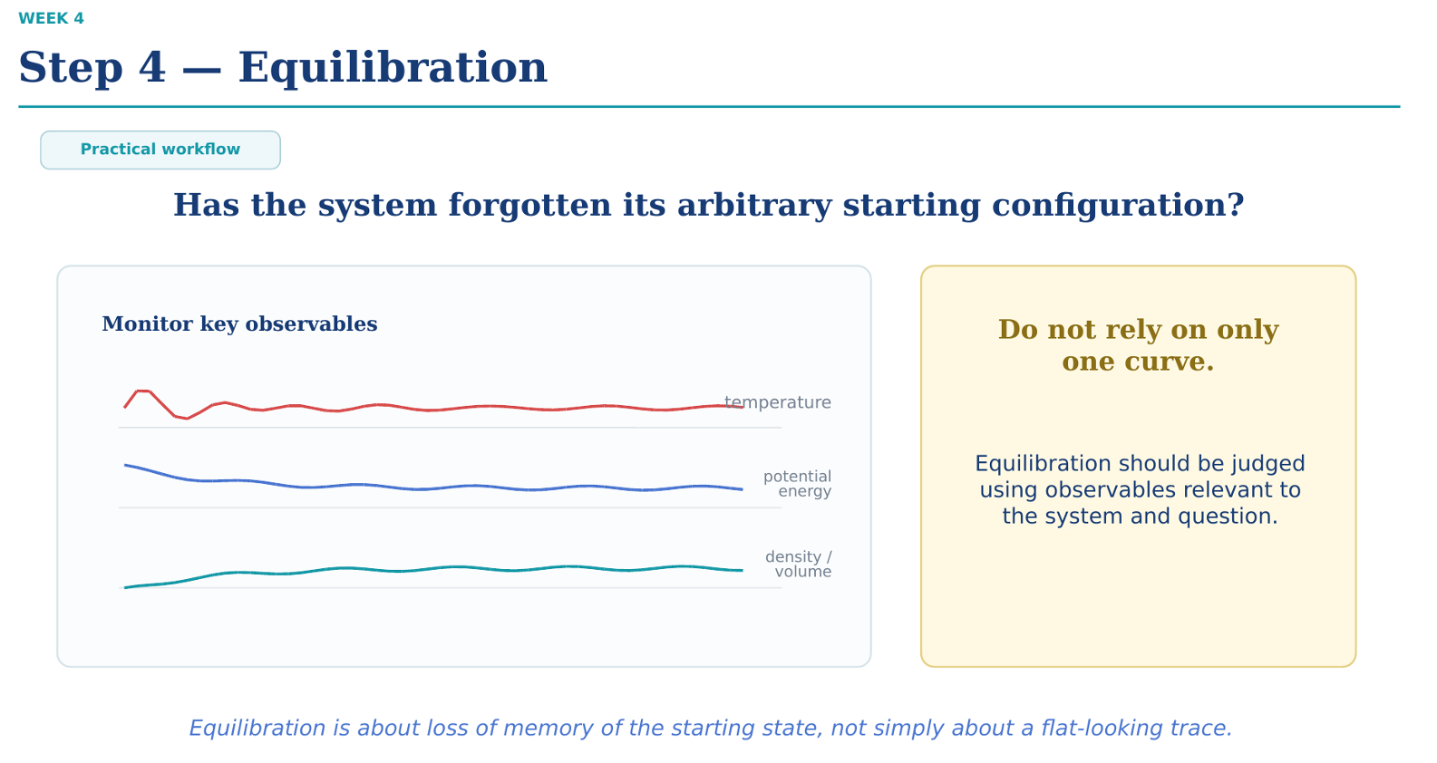
Slide Summary: Step 4 — Equilibration
- Core Objective: Erase the system's memory of its artificial initial arrangement and let it reach thermodynamic equilibrium at the target state.

- Monitor Key Observables: Track multiple thermodynamic properties over time until their running averages flatten out into stable thermal fluctuations:

  - Temperature: Verifies thermalization (usually during $NVT$).

  - Potential Energy: Verifies structural relaxation.

  - Density / Volume: Verifies volumetric equilibrium under external pressure (during $NPT$).

- Multi-Metric Validation: Never judge equilibrium from a single parameter; a flat temperature curve can conceal an un-equilibrated density or potential energy.

Core Takeaway
Equilibration is fundamentally about the loss of memory of the artificial starting state, ensuring production data reflects true equilibrium physics rather than initial setup artifacts.

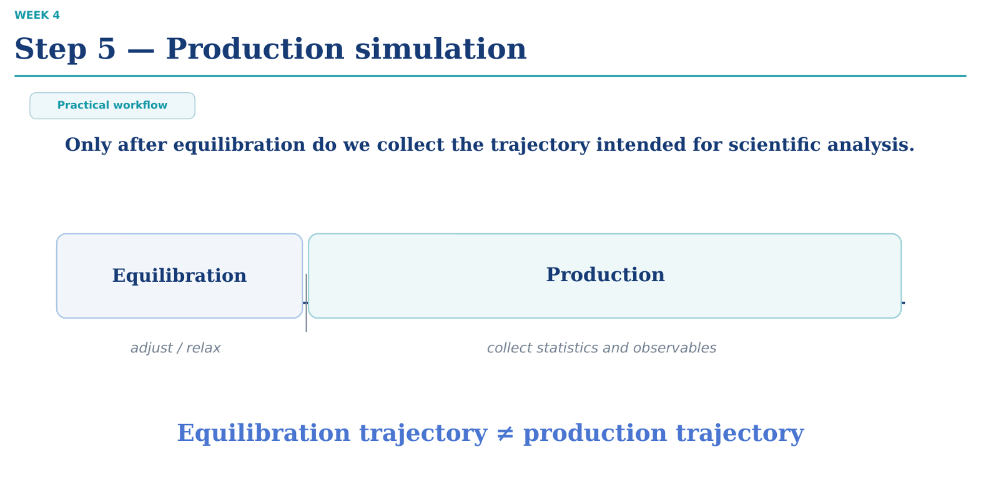
Slide Summary: Step 5 — Production simulation
- Data Collection Phase: The production run generates the actual trajectory used for physical analysis and calculating observables (e.g., diffusion coefficients, radial distribution functions, free energies).
- Equilibration vs. Production:
  - Equilibration: Purpose is to allow the system to adjust and relax to thermodynamic equilibrium; trajectory data from this phase is discarded.
  - Production: Purpose is to collect unbiased statistics from an already equilibrated state.

Key Takeaway
Equilibration trajectory $≠$ production trajectory—never mix equilibration data into your final scientific analysis, as doing so introduces unphysical relaxation artifacts into your statistics.

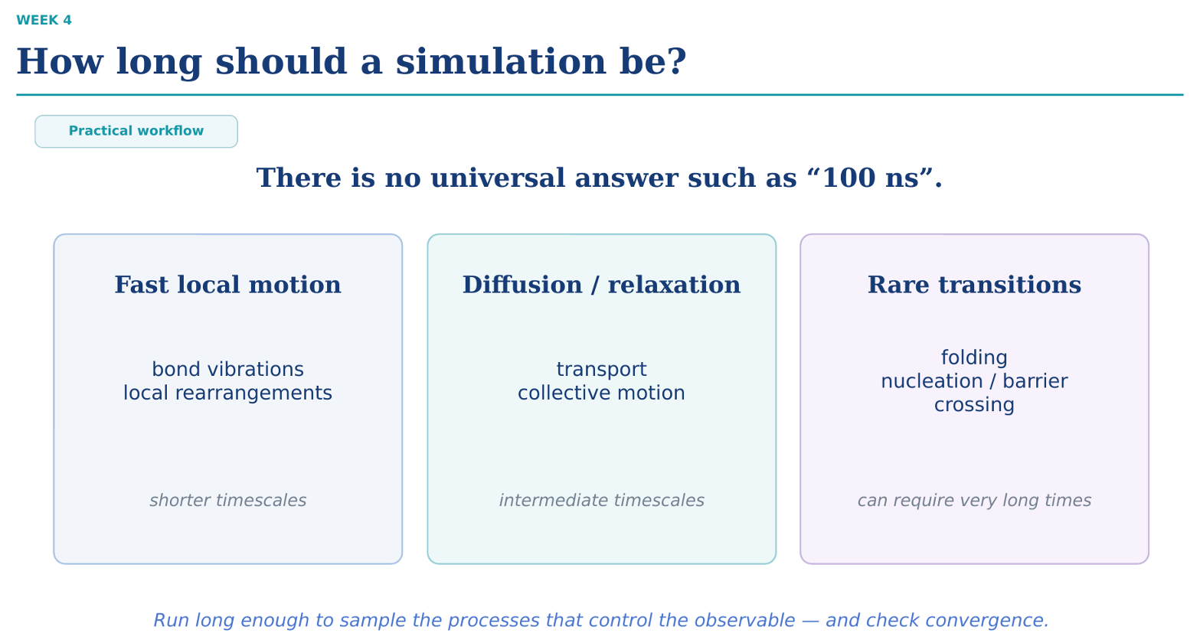
Slide Summary: How long should a simulation be?
- No Universal Length: Simulation length depends entirely on the physical phenomenon being studied—there is no standard length like "100 ns".
- Three Characteristic Timescales:
  - Fast local motion (Femtoseconds to Picoseconds): Bond vibrations, angle bending, and immediate solvent cage reorganizations.
  - Diffusion / relaxation (Nanoseconds): Molecular transport, density relaxation, and collective structural motions.

  - Rare transitions (Microseconds to Milliseconds+): Protein folding, crystal nucleation, phase transitions, and high-barrier conformational changes.

Core Takeaway
A simulation must run long enough to thoroughly sample the specific physical processes controlling your target observable, and its completion must be proven by checking convergence (verifying your calculated observables stabilize over time).

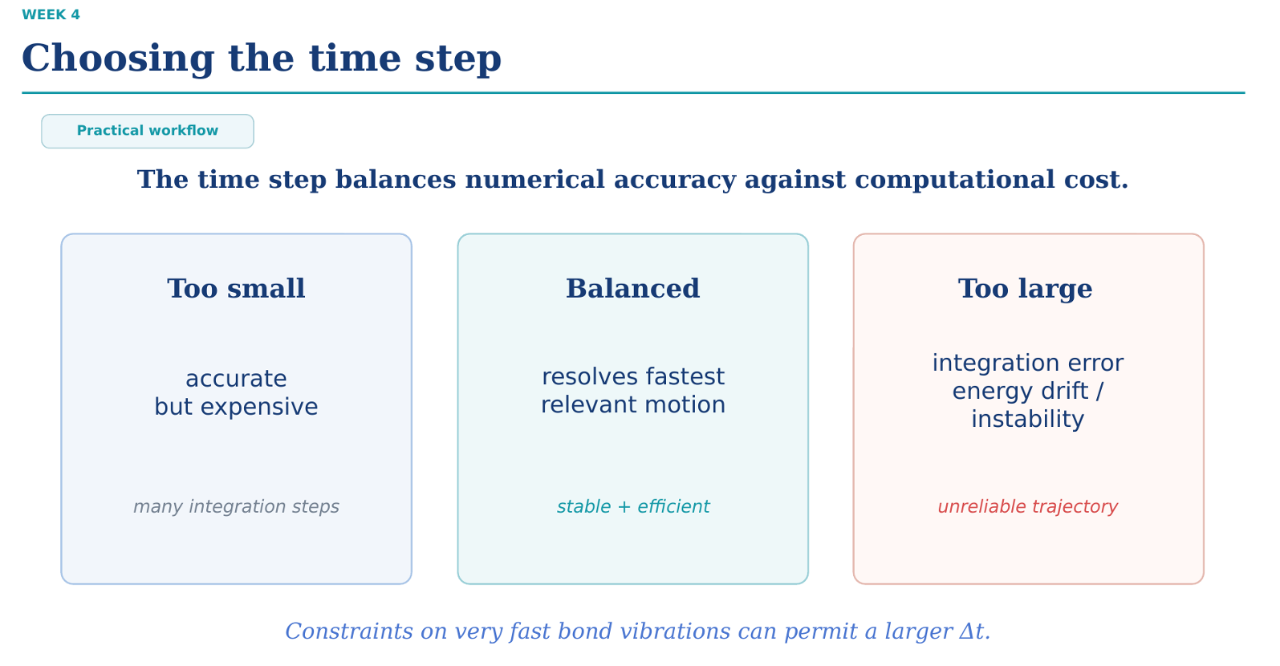
Slide Summary: Choosing the time step ($Δt$)
- Core Trade-off: Selecting the integration time step ($Δt$) requires balancing numerical accuracy against computational efficiency.
- Impact of Time Step Size:
  - Too Small ($Δt≪1\text{ fs}$): Highly accurate, but requires an excessive number of calculation steps to cover physical time, making the simulation computationally expensive.
  - Balanced ($Δt≈1\text{--}2\text{ fs}$): Resolves the fastest physical vibrations in the system while remaining stable and computationally efficient.
  - Too Large ($Δt>2\text{ fs}$ without constraints): Causes integration errors, total energy drift, numerical instability, and simulation crashes (exploding systems).
- Bond Constraints: Applying constraint algorithms (such as SHAKE or LINCS) to freeze the fastest bond vibrations (e.g., C-H bonds) allows you to safely increase $Δt$ from $1\text{ fs}$ to $2\text{ fs}$.

Core Takeaway
The time step must be smaller than the period of the fastest motion in the system (typically $≈10\text{ fs}$ for C-H bond stretches), requiring $Δt$ to be about $\frac{1}{10}\text{th}$ of that period to maintain integration accuracy.

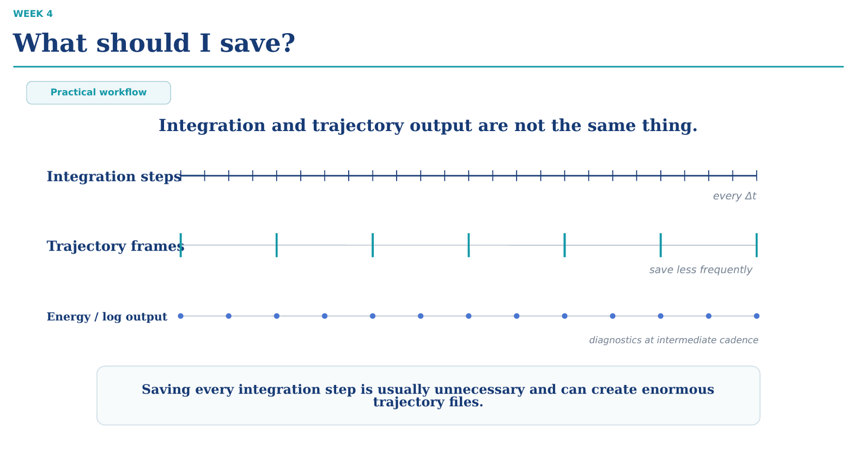
Slide Summary: What should I save?
- Integration Steps vs. Saved Output: The engine evaluates equations of motion at a tiny time step ($Δt$, e.g., every 1–2 fs), but you do not need to save every step to disk.
- Three Output Cadences:
  - Integration steps ($\text{every }Δt$): Internal computation loop calculated constantly by the simulator.
  - Trajectory frames ($\text{save less frequently}$): Atomic coordinates ($r$) saved periodically (e.g., every 10–100 ps / 5,000–50,000 steps) for visualization and structural analysis.
  - Energy / log output ($\text{intermediate cadence}$): Thermodynamic properties ($T,P,U,K$) logged at moderate frequency (e.g., every 1–10 ps) to track convergence and stability.

Core Takeaway
Saving every single integration step is completely unnecessary for post-processing and quickly results in unmanageably massive trajectory files (multi-terabyte scale).

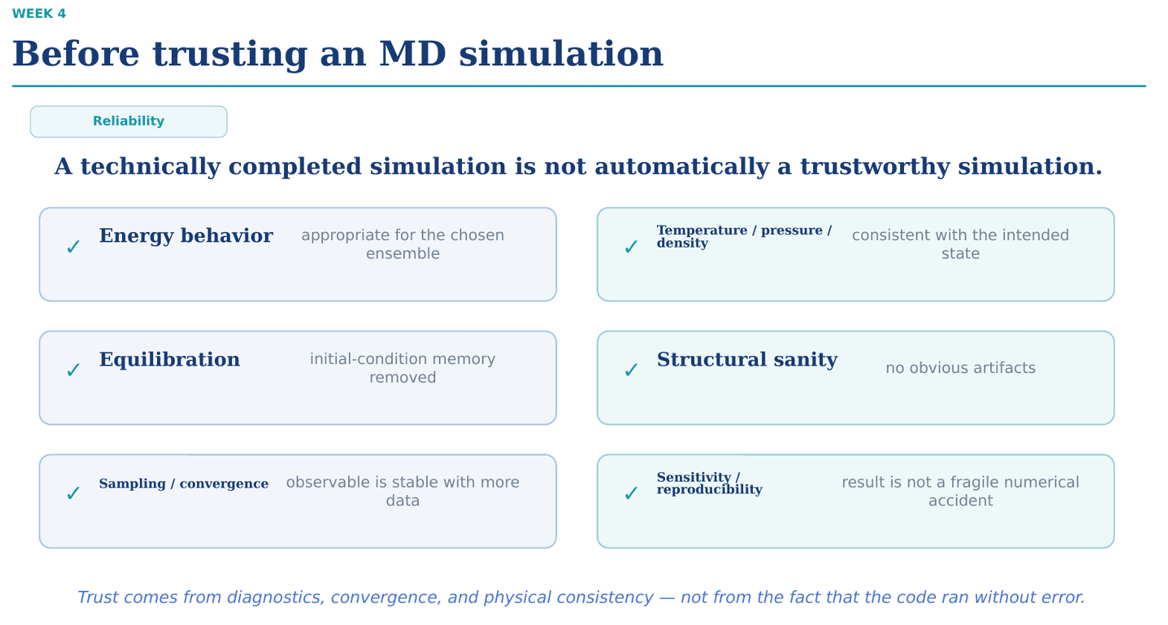
Slide Summary: Before trusting an MD simulation
- Execution $≠$ Reliability: Just because an MD simulation completed without throwing software errors does not mean the physics or data are valid.
- 6-Point Reliability Checklist:
  - Energy behavior: Conserved in $NVE$ or fluctuating appropriately around the target in thermostated ensembles.
  - Temperature / pressure / density: Fluctuate tightly around specified target values rather than drifting.
  - Equilibration: Initial-condition memory is fully erased before production data collection begins.
  - Structural sanity: Trajectory visualization confirms no molecular tearing, periodic boundary explosions, or unphysical vacuum bubbles.

  - Sampling / convergence: Computed observables (e.g., RMSD, diffusion coefficient) remain statistically stable when adding more simulation time.
  - Sensitivity / reproducibility: Results are reproducible across different random seeds/trajectories and resilient against minor numerical shifts.

Core Takeaway
Scientific trust comes from physical diagnostics, sampling convergence, and physical consistency—never simply from the fact that the simulation script finished running.
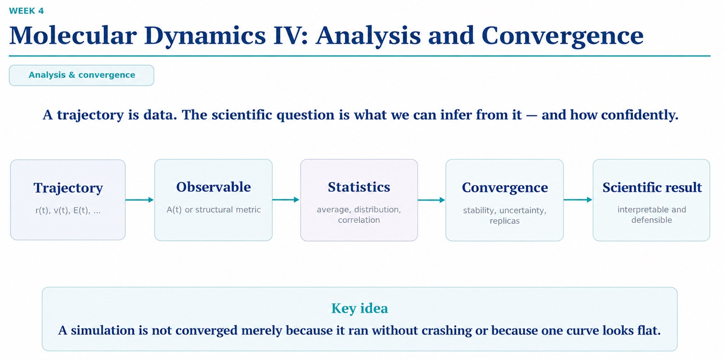
Slide Summary: Molecular Dynamics IV — Analysis and Convergence
- The Analytical Pipeline: Converting raw simulation data into a defensible scientific conclusion follows a 5-step pipeline:
  - Trajectory: Raw coordinate, velocity, and energy time-series data ($r\left(t\right),v\left(t\right),E\left(t\right)$).
  - Observable: Extraction of targeted physical properties or structural metrics ($A\left(t\right)$, RMSD, RDF).
  - Statistics: Computation of ensemble averages, probability distributions, and correlation functions.

  - Convergence: Quantitative evaluation of numerical stability, statistical uncertainty, and replica consistency.
  - Scientific result: Producing an interpretable, reproducible, and defensible conclusion.

Core Takeaway
A simulation trajectory is simply raw data—a run is not converged merely because it finished without software crashes or because a single plot trace visually flattens out.
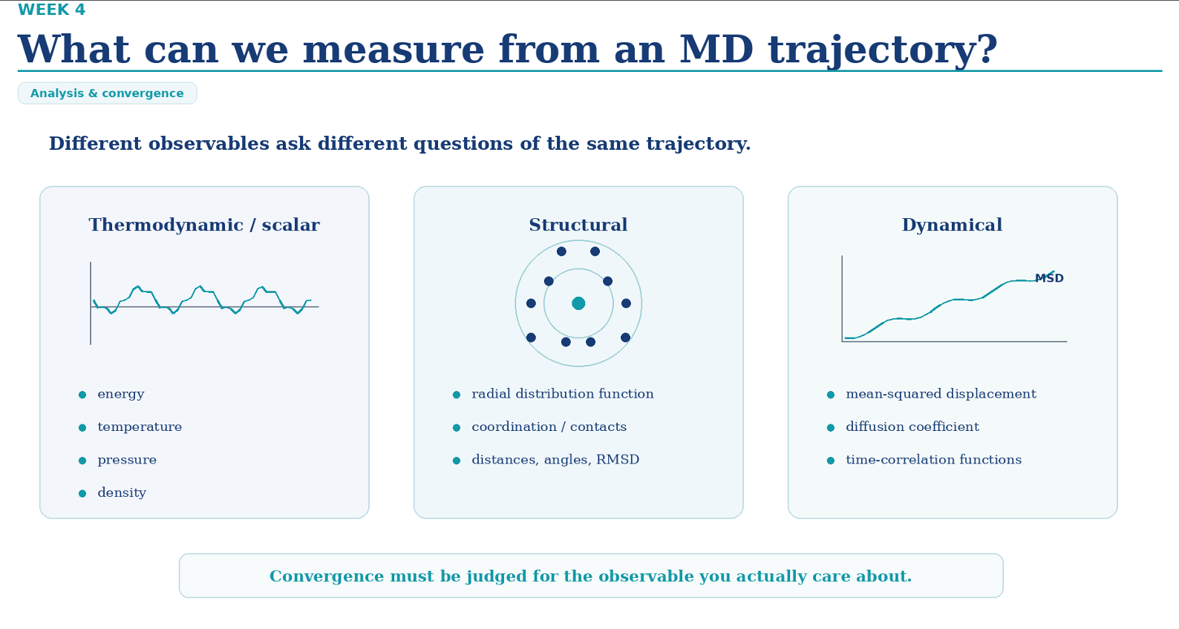
Slide Summary: What can we measure from an MD trajectory?
- Three Primary Categories of Observables:
  - Thermodynamic / Scalar: Macroscopic state variables ($T,P,U,ρ$) computed to confirm ensemble stability.
  - Structural: Spatial distributions and atomic arrangements (Radial Distribution Function $g\left(r\right)$, coordination numbers, RMSD, distances/angles).

  - Dynamical: Time-dependent transport and relaxation properties (Mean-Squared Displacement [MSD], self-diffusion coefficient $D$, velocity autocorrelation functions).

Core Takeaway
Convergence must be evaluated specifically for the physical observable you care about—a simulation that reaches thermodynamic scalar stability (e.g., flat temperature or energy) may still be far from converged for complex dynamical or structural properties.
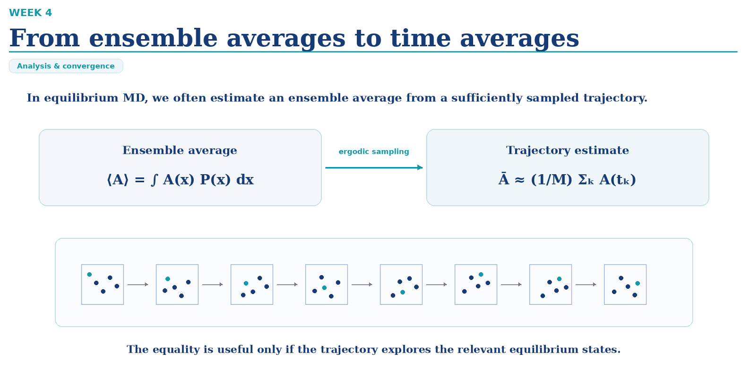
Slide Summary: From ensemble averages to time averages
- Ergodic Hypothesis in MD: Replaces a theoretical ensemble average $\left\langle A\right\rangle$ over all possible microstates $x$ with a discrete time average $\overline{A}$ calculated over $M$ trajectory snapshots:

$$\left\langle A\right\rangle =\int{A}\left(x\right)P\left(x\right) dx\underset{→}{\text{ergodic sampling}}\overline{A}≈\frac{1}{M}\sum_{k=1}^{M}{A}\left(t_{k}\right)$$
- Trajectory Estimation: A single, sufficiently long equilibrium MD trajectory is used to approximate macroscopic thermodynamic averages by sampling representative phase-space configurations over time.
- Ergodic Requirement: The mathematical equality between ensemble and time averages holds only if the simulation run time is long enough to fully explore all relevant equilibrium configurations and energy basins.

Core Takeaway
Time averages equal ensemble averages only under ergodic conditions—if your trajectory remains trapped in a single local energy minimum, the calculated trajectory average will fail to represent the true thermodynamic equilibrium state.

فرض ارگودیک (Ergodic Hypothesis) در شبیه‌سازی MD
مفهوم اصلی این است:
آیا می‌توانیم به‌جای بررسی هزاران سیستم مختلف، فقط یک سیستم را برای مدت طولانی شبیه‌سازی کنیم و همان میانگین را به دست آوریم؟
فرض ارگودیک می‌گوید در شرایط مناسب، بله!
۱. میانگین مجموعه‌ای (Ensemble Average) چیست؟
فرض کن یک مولکول می‌تواند در سه حالت مختلف قرار بگیرد:
حالت | انرژی | احتمال حضور
A | ۱۰ | ۵۰٪
B | ۲۰ | ۳۰٪
C | ۳۰ | ۲۰٪
در تعادل، سیستم با احتمال بیشتری در حالت A قرار می‌گیرد.
برای محاسبهٔ میانگین انرژی، انرژی هر حالت را در احتمال آن ضرب می‌کنیم:
\[ \langle E\rangle=0.5(10)+0.3(20)+0.2(30) \]
\[ \boxed{\langle E\rangle=17} \]
این همان Ensemble Average است.
یعنی میانگین‌گیری روی حالت‌های ممکن سیستم، با درنظرگرفتن احتمال تعادلی هر حالت.
۲. میانگین زمانی (Time Average) چیست؟
حالا فرض کن به‌جای بررسی تمام حالت‌های ممکن، یک شبیه‌سازی MD اجرا می‌کنیم.
در طول زمان، مولکول بین حالت‌های A و B و C جابه‌جا می‌شود.
مثلاً در ۱۰ لحظهٔ مختلف، انرژی‌های زیر را ثبت می‌کنیم:
\[ 10,\ 20,\ 10,\ 30,\ 10,\ 20,\ 10,\ 20,\ 30,\ 10 \]
میانگین زمانی برابر است با:
\[ \langle E\rangle_{\mathrm{time}}=\frac{170}{10}=17 \]
دوباره به عدد ۱۷ رسیدیم!
چرا؟ چون سیستم در طول شبیه‌سازی، حالت‌ها را متناسب با احتمال تعادلی آن‌ها مشاهده کرده است.
پس دو روش داریم:
- Ensemble Average: میانگین روی حالت‌های ممکن سیستم.
- Time Average: میانگین روی حالت‌هایی که یک سیستم در طول زمان تجربه می‌کند.
۳. فرض ارگودیک دقیقاً چیست؟
فرض ارگودیک می‌گوید اگر سیستم ارگودیک و در تعادل باشد، میانگین زمانی در حد زمان بی‌نهایت با میانگین مجموعه‌ای برابر می‌شود.
\[ \boxed{ \langle A\rangle_{\mathrm{time}} = \langle A\rangle_{\mathrm{ensemble}} } \]
بنابراین در MD می‌توانیم با اجرای یک trajectory طولانی، خواص تعادلی سیستم را تخمین بزنیم.
اما یک مشکل مهم وجود دارد!
۴. اگر مولکول در یک حالت گیر کند چه می‌شود؟
فرض کن مولکول دو حالت پایدار دارد:
- حالت A با انرژی پایین
- حالت B با انرژی پایین
بین این دو حالت یک مانع انرژی (Energy Barrier) وجود دارد.
فرض کن در تعادل، احتمال حضور در هر حالت ۵۰٪ است.
اگر مقدار یک خاصیت در حالت A برابر ۲ و در حالت B برابر ۸ باشد:
\[ \langle X\rangle=0.5(2)+0.5(8)=5 \]
اما اگر شبیه‌سازی فقط حالت A را مشاهده کند، میانگین زمانی تقریباً برابر ۲ خواهد بود.
پس:
\[ \langle X\rangle_{\mathrm{time}}\approx2 \]
درحالی‌که میانگین واقعی تعادلی برابر ۵ است.
علت اختلاف چیست؟
مولکول نتوانسته از مانع انرژی عبور کند و حالت B را نیز نمونه‌برداری کند.
به این مشکل، Insufficient Sampling می‌گوییم.
۵. ارتباط با Molecular Dynamics
در MD معمولاً از یک trajectory برای محاسبهٔ خواصی مثل انرژی متوسط، ساختار متوسط و توزیع‌های تعادلی استفاده می‌کنیم.
اما باید مطمئن شویم که شبیه‌سازی به‌اندازهٔ کافی از حالت‌های مهم نمونه‌برداری کرده است.
حتی اگر سیستم از نظر ریاضی ارگودیک باشد، ممکن است عبور بین حالت‌ها آن‌قدر کند باشد که در مدت شبیه‌سازی اتفاق نیفتد.
این موضوع یکی از انگیزه‌های استفاده از روش‌های نمونه‌برداری پیشرفته و Rare-Event Sampling است.
خلاصهٔ انگلیسی برای جزوه
Copy
Ergodic Hypothesis in MD
- Ensemble average: Average over possible microstates, weighted by their equilibrium probabilities.
- Time average: Average calculated from snapshots along a single MD trajectory.
- Ergodic hypothesis: In an ergodic equilibrium system, the infinite-time average equals the ensemble average.
- Insufficient sampling: If a trajectory remains trapped in one energy basin, its time average may not represent the equilibrium ensemble.
Key takeaway: A sufficiently sampled equilibrium MD trajectory can estimate ensemble averages using time averages.

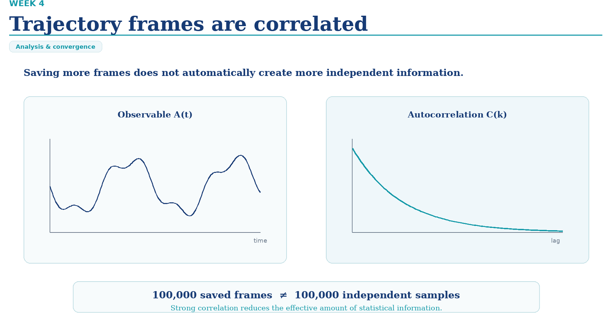
Slide Summary: Trajectory frames are correlated
- Temporal Correlation: Consecutive frames in an MD trajectory are closely linked in time, meaning adjacent snapshots carry nearly redundant statistical information.
- Autocorrelation Function $C\left(k\right)$: Measures how strongly an observable $A\left(t\right)$ correlates with itself over a time lag $k$. The curve decays over time as the system loses memory of its past state.
- Effective Sample Size: Because of strong autocorrelation, saving more frames does not equal getting more independent data points ($100,000\text{ saved frames}≠100,000\text{ independent samples}$).
Core Takeaway
Statistical uncertainty depends on the number of uncorrelated (independent) samples, not the total number of saved frames—high-frequency saving inflates file size without adding real statistical power.
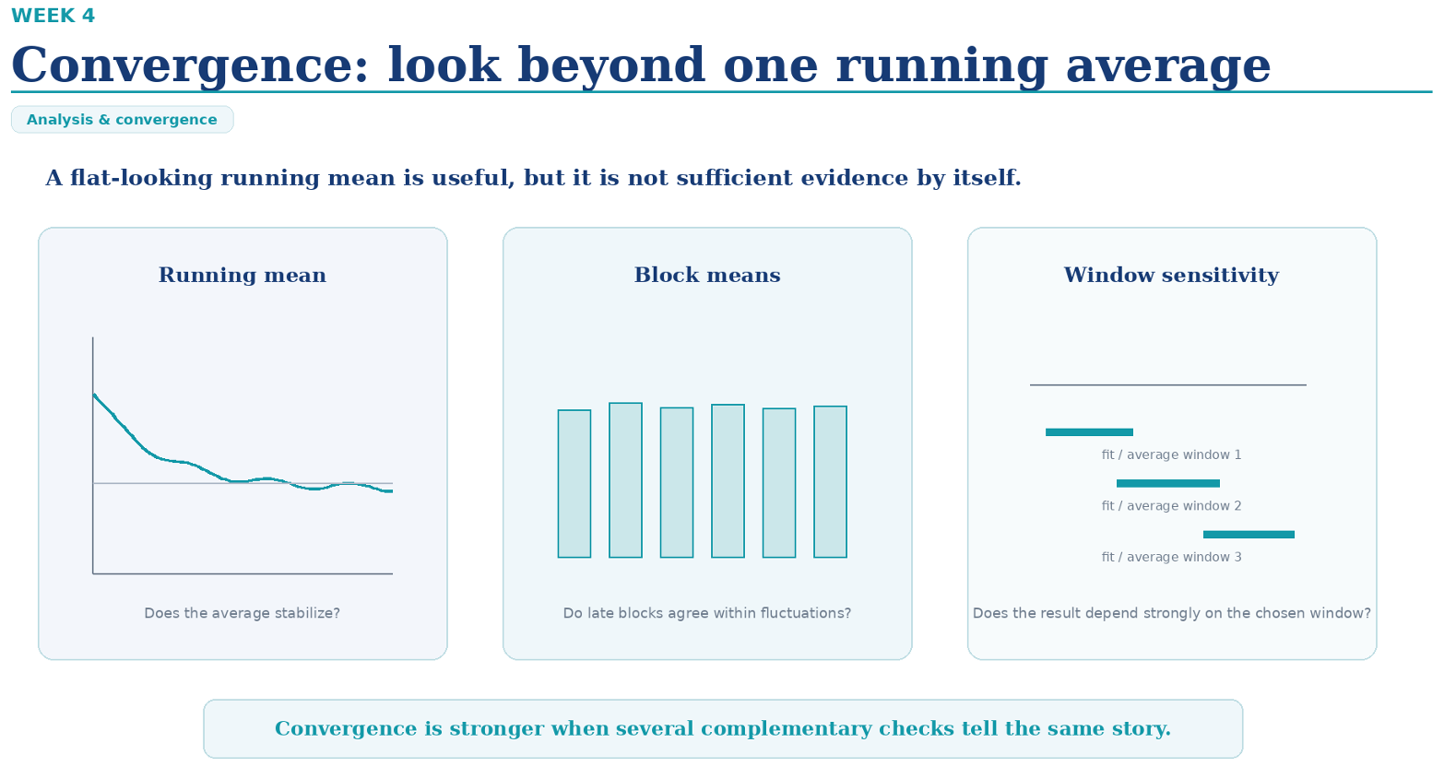
Slide Summary: Convergence: look beyond one running average
- One Flat Line Is Not Enough: A running average line looking flat is a good start, but it doesn't guarantee your simulation has truly converged.
- Three Checks for Real Convergence:
  - Running mean: Checks if the overall cumulative average has stopped drifting and leveled off over time.

  - Block means: Splits the trajectory into equal time blocks to check if independent sections give consistent results.

  - Window sensitivity: Calculates averages using different time windows (e.g., first half vs. second half vs. middle) to make sure your calculated answer doesn't change depending on which range of time you pick.

Core Takeaway
Never rely on just one flat graph to claim a simulation is done—true convergence requires multiple diagnostic tests pointing to the same stable answer.
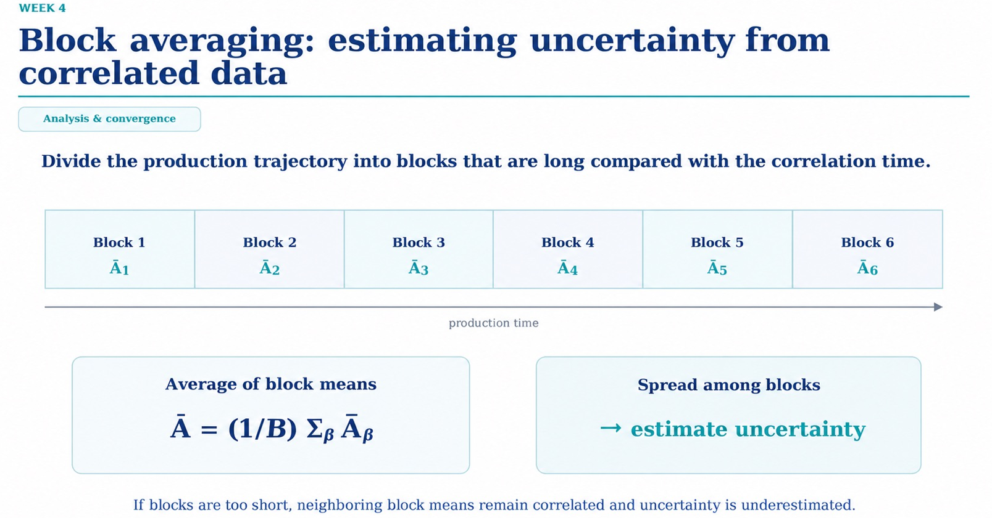
Slide Summary: Block averaging: estimating uncertainty from correlated data
- The Problem with Raw Trajectories: Because adjacent trajectory frames depend on each other (they are correlated), standard statistical formulas will understate the real error.
- The Block Averaging Solution:
  - Split the production trajectory into $B$ large blocks.

  - Make sure each block length is much longer than the autocorrelation time so the blocks act like independent experiments.
  - Calculate the average value ${\overline{A}}_{β}$ for each block.

- Two Main Calculations:
  - Average of block means: $\overline{A}=\frac{1}{B}\sum_{β}{{\overline{A}}_{β}}$ gives the overall mean value.
  - Spread among blocks: Measuring how much the block averages (${\overline{A}}_{1},{\overline{A}}_{2},…,{\overline{A}}_{B}$) differ from each other gives an accurate estimate of true statistical error and uncertainty.

Core Takeaway
Block averaging grouping correlated frame data into long, independent blocks allows calculating real statistical error bars; using blocks that are too short leaves neighboring blocks correlated and tricks you into underestimating error.
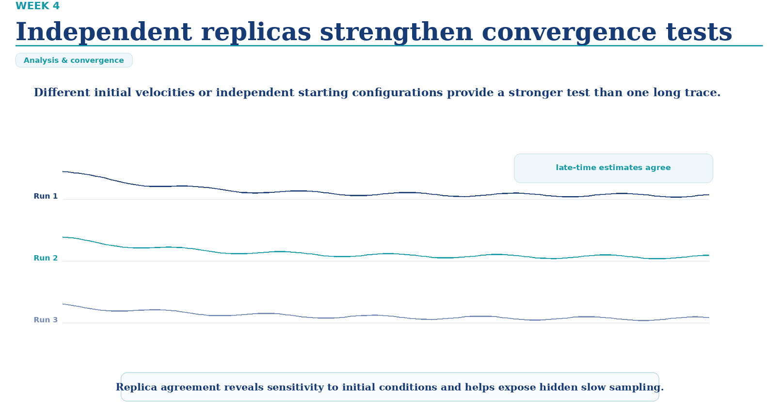
Slide Summary: Independent replicas strengthen convergence tests
- Replicas vs. Single Long Run: Running multiple independent simulation runs (replicas) starting with different initial velocities or different starting structures gives a much stronger test of real convergence than relying on a single long simulation trace.
- Late-Time Agreement:
  - In true equilibrium, independent replicas starting from different conditions should all converge to the exact same average value over time.
  - If different runs stabilize at different values, the system has not sampled enough or is stuck in different local energy wells.
- Exposing Hidden Slow Motion: Replicas reveal if your results are overly sensitive to starting conditions and help catch hidden slow physical processes that a single run might miss.

Core Takeaway
Convergence is proven when multiple independent runs reach the exact same conclusion—relying on a single simulation run leaves you vulnerable to hidden sampling bias and unobserved energy barriers.
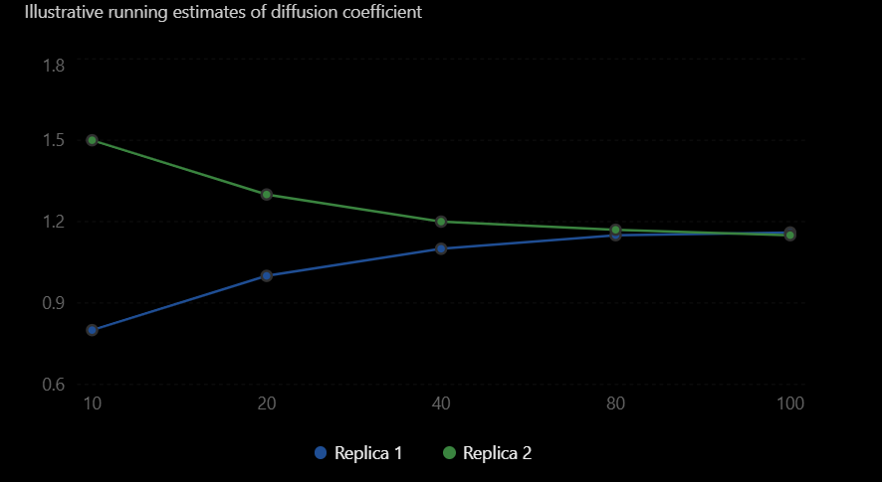
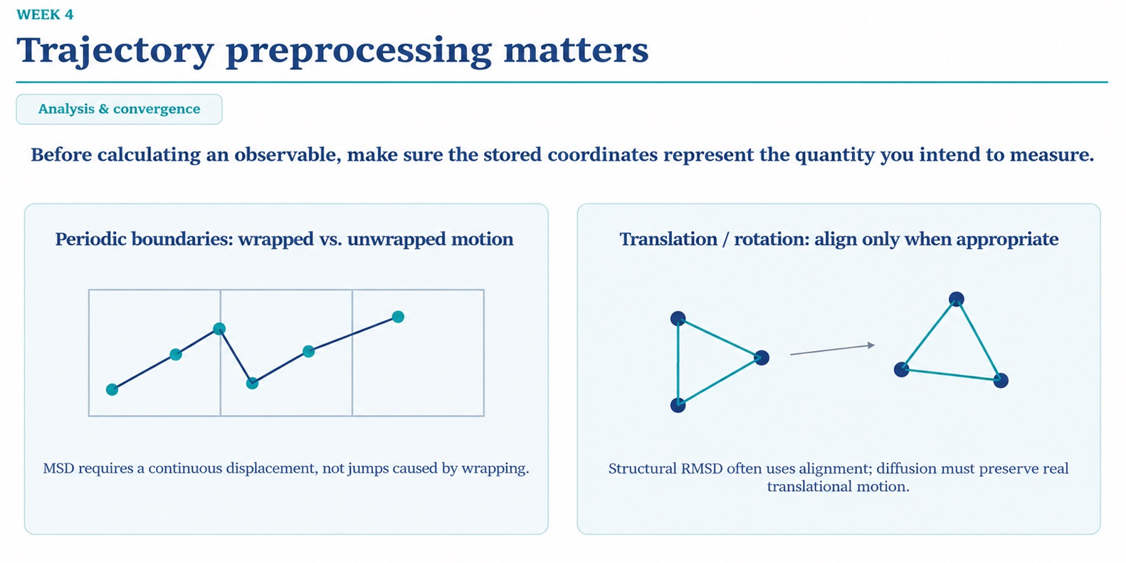
Slide Summary: Trajectory preprocessing matters
- Prepare Data Before Analysis: Raw output coordinates must be cleaned up and formatted to fit the specific measurement being performed.

- Periodic Boundaries (Wrapped vs. Unwrapped Motion):
  - In simulations, atoms that cross a box boundary jump to the opposite side (wrapping).
  - Calculating metrics like Mean-Squared Displacement (MSD) or diffusion requires continuous unwrapped motion to avoid fake position jumps.
- Translation & Rotation (Aligning Coordinates):
  - Measuring structural changes (like RMSD) requires removing whole-molecule translation and rotation to isolate shape changes.
  - Calculating physical transport properties (like diffusion) requires keeping actual translation and rotation intact.

Core Takeaway
Raw trajectory coordinates are not always ready for direct calculation—you must preprocess the frames (wrapping/unwrapping or structural alignment) according to the specific observable you are measuring.
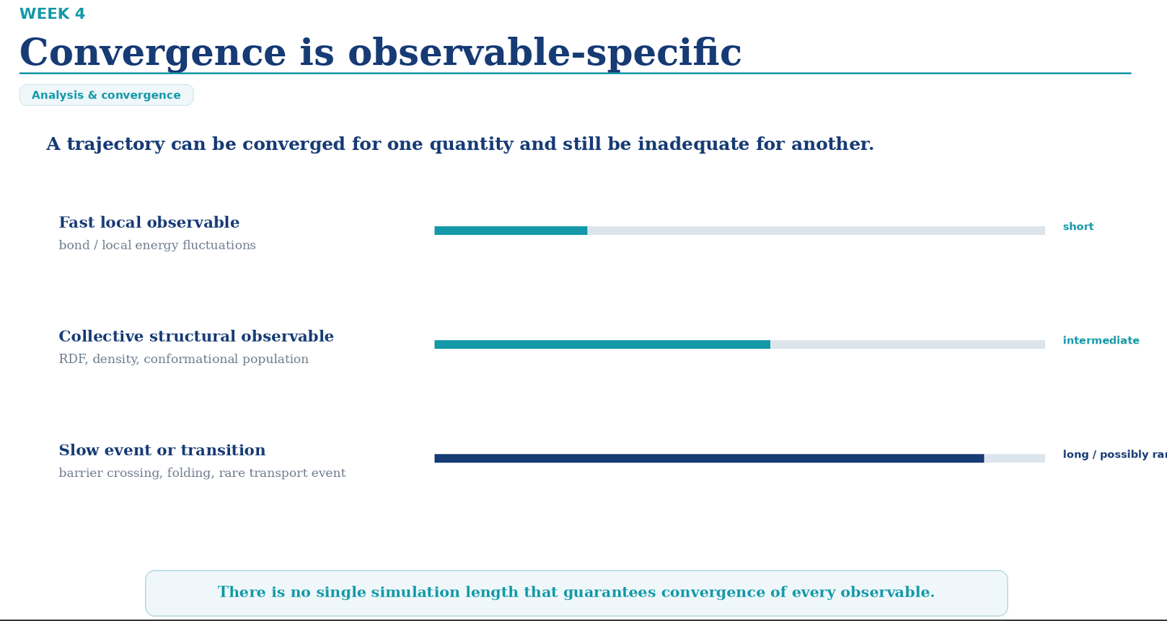
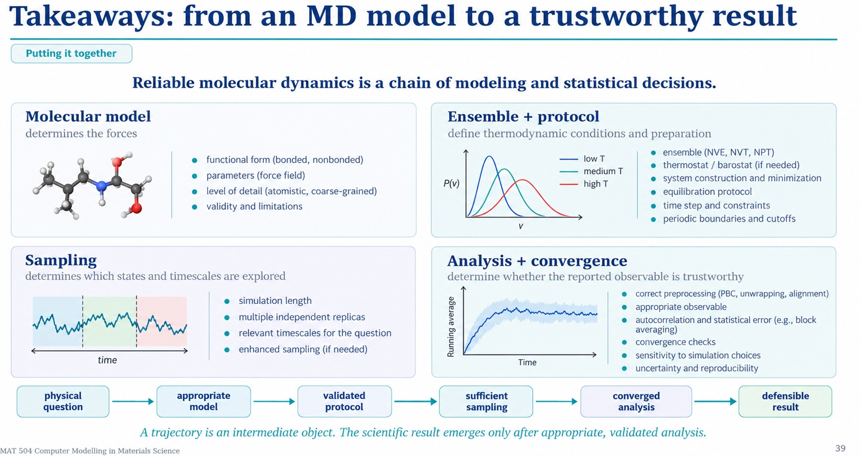
Slide Summary: Takeaways: from an MD model to a trustworthy result
- The Core Message: Reliable molecular dynamics is a continuous chain of modeling and statistical decisions; a trajectory is merely an intermediate data object, and a scientific result emerges only after thorough validation and analysis.

- 4 Pillars of the MD Chain:
  - Molecular model: Dictates force evaluations via functional forms (bonded/non-bonded), force field parameters, resolution level (atomistic vs. coarse-grained), and physical limits.
  - Ensemble + protocol: Defines thermodynamic ensembles ($NVE,NVT,NPT$), thermostats/barostats, system setup, energy minimization, equilibration, time step choice ($Δt$), and cutoff settings.
  - Sampling: Ensures physical timescale coverage via appropriate trajectory lengths, multiple independent replicas, and enhanced sampling methods where needed.
  - Analysis + convergence: Confirms data trustworthiness through trajectory preprocessing (PBC unwrapping, alignment), autocorrelation handling (block averaging), multi-window convergence checks, and error estimation.

Complete All-in-One MD Workflow & Analysis Review
Here is the complete, end-to-end framework uniting the setup, execution, diagnostics, and statistical analysis of a Molecular Dynamics simulation pipeline:

1. Simulation Setup & Practical Workflow
- System Minimization: Energy minimization (downhill gradient descent) is a pre-simulation cleanup step to remove atomic clashes and prevent numerical explosions; it performs no physical thermal sampling.

- Equilibration: Relaxes the system to the target thermodynamic ensemble ($NVT$/$NPT$). You discard the equilibration trajectory history to eliminate non-equilibrium artifacts, but keep the final relaxed frame as the starting structure for production.

- Time Step ($Δt$): Balances numerical accuracy against computational cost. Typical steps are $1\text{--}2\text{ fs}$ ($≈\frac{1}{10}\text{th}$ of the fastest bond vibration period). Algorithms like SHAKE or LINCS constrain hydrogen bond vibrations to allow larger time steps safely.

- Saving Cadence: Integration steps run every $Δt$, but saved trajectory frames and thermodynamic log files are written at much lower frequencies to prevent terabyte-scale file inflation.

2. Trajectory Preprocessing & Measurement
- Preprocessing Rules:

  - Unwrapping: Continuous spatial properties like Mean-Squared Displacement (MSD) and self-diffusion require continuous, unwrapped coordinates across periodic boundary conditions (PBC).

  - Alignment: Structural metrics like RMSD require removing rigid body translation and rotation; dynamic transport calculations must preserve real motion.

- Types of Observables:

  - Thermodynamic/Scalar: Temperature, pressure, total energy, density.

  - Structural: Radial Distribution Function $g\left(r\right)$, coordination numbers, RMSD, distances/angles.

  - Dynamical: Mean-Squared Displacement (MSD), self-diffusion coefficient $D$, time correlation functions.

3. Convergence, Ergodicity & Statistical Uncertainty
- Ergodic Principle: In equilibrium MD, ensemble averages $\left\langle A\right\rangle$ are approximated by long time averages $\overline{A}$. This holds true only if the simulation explores all relevant equilibrium states.

- Correlated Data & Block Averaging: Adjacent trajectory frames are temporally correlated ($100,000\text{ frames}≠100,000\text{ independent samples}$). Block averaging divides the production trajectory into blocks longer than the autocorrelation time to calculate genuine statistical error bars without underestimation.

- Validation Beyond One Curve:

  - Execution $≠$ Reliability: Running without software crashes does not make a simulation scientifically valid.

  - Multi-Angle Checks: True convergence requires verifying running means, testing block means across independent segments, evaluating window sensitivity, and confirming that independent replicas (with varied initial velocities/configurations) reach identical late-time equilibrium values.

برای اینکه بتوانید این متن را به‌صورت کاملاً تمیز، شکیل و بدون بهم‌ریختگی در نرم‌افزار Word پیست (Paste) کنید، آن را با فرمت‌بندی استاندارد نگارش و کادربندی‌های مشخص در ادامه آورده‌ام.

پس از کپی کردن متن، هنگام پیست در Word می‌توانید از گزینه Keep Source Formatting یا Merge Formatting استفاده کنید.

خلاصه جامع و کاربردی شبیه‌سازی دینامیک مولکولی (MD)
از مدل‌سازی تا رسیدن به نتیجه قابل‌اعتماد علمی
این سند خلاصه و مرور جامع تمامی مراحل یک شبیه‌سازی کامل MD است که بر اساس مثال محاسبه ضریب نفوذ مایع لنارد-جونز (Lennard–Jones) پیاده‌سازی شده است.

🎯 مسئله فیزیکی (Physical Question)
- سؤال اصلی: ضریب نفوذ ($D$) یک مایع چقدر است؟

- مسیر کلی حل:

$$\text{Physical Question}⟶\text{MD Simulation}⟶\text{Analysis}⟶\text{Result}$$
📌 مراحل چهارگانه شبیه‌سازی (MD Pipeline)
۱. مدل مولکولی (Molecular Model)
در اولین گام، نحوه برهم‌کنش ذرات مشخص می‌شود. برای مایع ساده از پتانسیل لنارد-جونز (Lennard–Jones) استفاده می‌شود:

$$U\left(r\right)=4ϵ\left[{\left(\frac{σ}{r}\right)}^{12}-{\left(\frac{σ}{r}\right)}^{6}\right]$$
- تنظیمات واحد‌های کاسته (Reduced Units):

$$ϵ=σ=m=k_{B}=1$$
- سؤال کلیدی این مرحله: آیا مدل انتخابی برای توصیف فیزیک مایع مورد نظر مناسب است؟

۲. تنظیم شرایط و پروتکل (Ensemble + Protocol)
تعیین شرایط فیزیکی، ترمودینامیکی و تنظیمات عددی شبیه‌سازی:

- تعیین تعداد ذرات و ابعاد جعبه شبیه‌سازی.

- اعمال شرایط مرزی تناوبی (PBC) برای شبیه‌سازی رفتار مایع حجیم (Bulk).

- تعادل‌رسانی اولیه سیستم در آنسامبل $NVT$ در دمای هدف ($T=1$).

- اجرای شبیه‌سازی اصلی (Production) در آنسامبل $NVE$ برای بررسی حرکت طبیعی ذرات.

- انتخاب گام زمانی ($Δt$) و فاصله قطعی (Cutoff) مناسب.

- سؤال کلیدی این مرحله: آیا شبیه‌سازی از نظر فیزیکی و عددی درست آماده شده است؟ (مثلاً عدم وجود رانش انرژی کل در $NVE$).

۳. نمونه‌برداری (Sampling)
تولید Trajectory با زمان کافی و استفاده از نسخه برداری‌های مستقل (Replicas):

خروجی | Seed | Replica
Trajectory 1 | 504 | 1
Trajectory 2 | 509 | 2
- نکته: هر دو نسخه دارای شرایط فیزیکی یکسان هستند اما مسیر حرکت ذرات متفاوت است.

- سؤال کلیدی این مرحله: آیا به‌اندازه کافی از فضای فاز و حالت‌های مهم سیستم نمونه‌برداری شده است؟ (در صورت کند بودن فرایند، استفاده از Enhanced Sampling ضروری است).

۴. تحلیل داده‌ها و همگرایی (Analysis + Convergence)
استخراج خاصیت فیزیکی و محاسبه خطای آماری:

- پیش‌پردازش: استفاده از مختصات Unwrapped برای حذف پرش‌های مرزی ناشی از PBC.

- محاسبه جابه‌جایی میانگین مربعات (MSD):

$$MSD\left(t\right)=\left\langle |r\left(t\right)-r\left(0\right)|2\right\rangle$$
- محاسبه ضریب نفوذ در سیستم دوبعدی:

$$\boxed{D=\frac{1}{4}\frac{d\left(MSD\right)}{dt}}$$
ارزیابی همگرایی و خطای آماری:
- Running Mean: بررسی پایداری تخمین در طول زمان.

- Block Averaging: محاسبه خطای آماری واقعی با حذف همبستگی زمانی.

- Window Sensitivity: اطمینان از عدم وابستگی نتیجه به بازه زمانی انتخابی.

- Independent Replicas: بررسی سازگاری نتایج بین اجراهای مستقل.

- نتیجه نهایی گزارش‌شده:

$$\boxed{D=0.25±0.02}$$
📊 جدول خلاصه مراحل شبیه‌سازی
مرحله | کار اصلی | پیامد خطا در این مرحله
Molecular Model | انتخاب پتانسیل و نیروها | فیزیک سیستم اشتباه می‌شود
Ensemble + Protocol | انتخاب شرایط ترمودینامیکی و تنظیمات | شبیه‌سازی از نظر عددی/فیزیکی نامعتبر می‌شود
Sampling | تولید Trajectory کافی و Replicas | حالت‌های مهم سیستم دیده نمی‌شوند
Analysis + Convergence | پیش‌پردازش، محاسبه خاصیت و عدم‌قطعیت | نتیجه نهایی گمراه‌کننده یا غلط می‌شود
💡 مهم‌ترین پیام کلید درس (Key Takeaway):

"A trajectory is an intermediate object. The scientific result emerges only after appropriate, validated analysis."

یک Trajectory صرفاً داده خام است؛ نتیجه علمی تنها پس از تحلیل درست، محاسبه دقیق خطای آماری و اطمینان از نمونه‌برداری کافی به دست می‌آید.
📄 English Summary (For Notes)
Plaintext
From an MD Model to a Trustworthy Result:

1. Molecular Model: Choose a suitable potential and force field.
2. Ensemble + Protocol: Define thermodynamic conditions, equilibration, production, and numerical settings.
3. Sampling: Generate sufficiently long trajectories and independent replicas.
4. Analysis + Convergence: Preprocess coordinates, calculate observables, check convergence, and estimate uncertainty.

Example: Lennard–Jones fluid → NVT equilibration → NVE production → Unwrapped coordinates → MSD → Diffusion coefficient → Uncertainty.

Key Takeaway: A reliable MD result requires a valid model, appropriate protocol, sufficient sampling, and statistically validated analysis.

